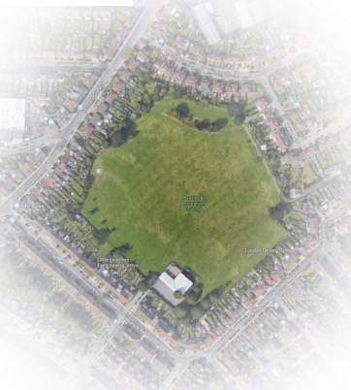

HAVELOCK RECREATION GROUND

Management Plan 2018 - 2028

Acknowledgements:
Friends of Havelock Rec (FOHR)
Friends of Bromley town Parks
idverde

Title: Management Plan for Havelock Recreation Ground

Contents

The Park.
About This Plan
Demographics
History and Heritage
Social Links
Summary of improvements since 2015
Policy and Strategic Context
Plans to Improve the Park
Site Management
Sustainability
11. Document review and site / work review
Appendices:
Including survey results and idverde policy documents referred to in the main body.

Authorship: Caroll Long, Idverde Community Manger. Emma Prescott, Chair of Friends of Havelock. Kerry Hood, Friends of Havelock.
Date created: November 2018
Date last updated: (in draft form)

1. The Park.

Havelock Recreation Ground is located in Bromley Town Ward of the London Borough of Bromley Local Authority.
Havelock Recreation Ground is a modest, square, largely level site of approx. 9 hectares surrounded by terraced housing and blocks of flats. There is a ‘B’ road on the west side (with entrance) whilst the remaining sides are minor roads.
The park has unrestricted access.
The locals also call it the ‘Bricki
e’ or ‘Brickfield’ because it is the site of a former brickworks and pits for the Lord of the Manor. Subsequently British Gas (or it’s predecessor) purchased it to dump the waste from the former town gas works and rubble from the Blitz. There is a nursery in the SE corner (about 1/8 of the site) that is the successor to Milwall FC’s sports pavilion. There is a dip in the NW corner, on the site of the smaller first quarry that appears in older maps. It is bounded by the gardens of residential housing, (meaning it is not visible from the surrounding roads) except along the north side, where there is a chain link road and a green lane to Waldo Road dump.

Over the years various trees have been planted around the perimeter, some of which have survived. Since the friends group was created in the spring 2015, they have also planted shrubs in a couple of places.
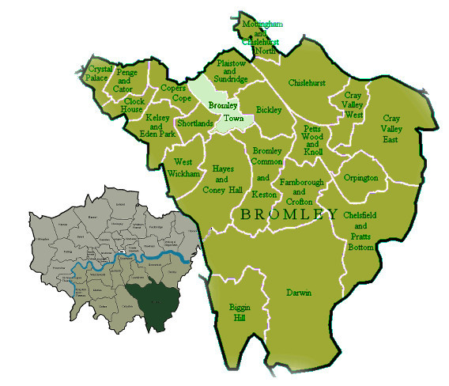
The Town Ward is in the north of Bromley borough, which is in the SE of Greater London

In 2015 the park was suggested to the Education Funding Agency as the site for La Fontaine school, by the council officer for Development and Regeneration. This was the 3rd attempt to dispose of all or part of the site, which has made residents quite defensive about it and distrustful of the council; they have a tendency for accosting high-vis workmen and asking them what they are doing… which is unfortunate for the environment agency workers who don’t want to say they’re monitoring the landfill.

People use the park for walking their dogs (as it has fences around it and feels secure), playing games, enjoying the open space and for events by the friends (see Appendix A2Full survey results for a full list). The park is also the best place, for a long way, to see a sunset (because of the open aspect).
Address: Havelock Road, Bromley, BR2 9NY
OS Land ranger Map Sheet 177 Grid Ref: TQ419681
Latitude: 51.3942 Longitude: 0.038221
Train links are Bickley Station and Bromley South Station.
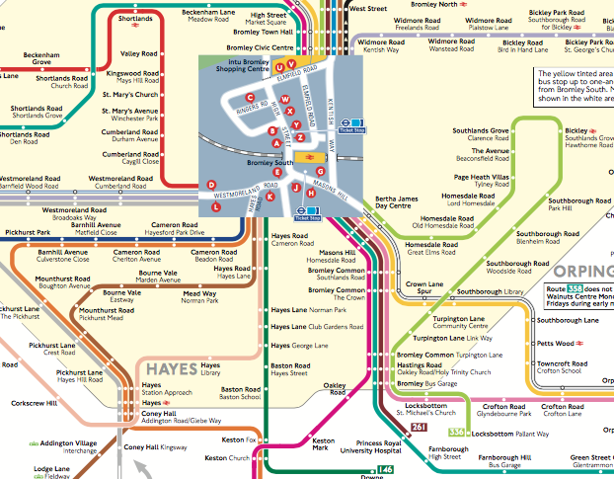
Local Bus Route map
It is the only non-ornamental park within the Town Ward, and is in the bottom corner, close to the A21.
Bus links nearby include 61, 208, 261, 269, 358, and 336

Friends Events include:
- Big Lunch
- Birdbox and Butterfly Day
- Fun Day
- Other ad-hoc events, from Easter Sports Day to Bulb Planting.

2. About This Plan

This is the first management plan for Havelock Recreation Ground.
It is expected that it would have minor revisions every 2 years.
The layout attempts to be concise, with appendices to explore information, such as survey results, policies, and census data, in full.

2.1 Aim:
The intention is to prepare a plan to develop a strategic and practical framework to improve the park for all parties with an interest.
The purpose of this plan is to:
- Identify, discuss and resolve issues relating to park infrastructure, park users and available resources
- Describe the method of managing and maintaining Havelock Recreation Ground
- Identify and address who is responsible for specific aspects of management and maintenance
- Deliver a benchmark against which delivery and performance can be measured.
- Share knowledge and experiences

2.3 Authorship:
The plan has been drawn up by Kerry Hood from the Friends of Havelock Rec (FOHR), with the collaboration of our committee and the chair Emma Prescott. A template was provided by Caroll Long (as cited on this Friends Forum list) the park’s officer at the council contractors, Idverde.

2.4 Consultation:
Park users were surveyed so that they had a chance to input into the process. Initially this was by interviewing them on the field, then it the consultation was published in the friend’s email newsletter and a link provided on their website. Finally, the survey was taken around to the local shops and businesses so that they could have an input. There was no response from this exercise.

3. Demographics
The park is in the SE corner of the Bromley Town ward. The surrounding roads are inhabited by a blue/white collar, white and mixed race people.
These are the roads that many of the park users live in:
The columns are derived from the survey results of (1) the 70 results in 2018; (2) the 2015 one for the village green application of 90 results. Homesdale road is characterised by a lot of flats; some older ones above the shops, and many in the new blocks (since the year 2000) at the A21 end.
Census data was obtained from Streetcheck website, who had already categorised it. It was collated over several of the census areas close to the park (see Appendix A1):
Housing Type: | Flats make up the largest type at 35% (which will increase at the next census), followed by semi at 26% and terrace at 22%
Housing Tenure | 40% are mortgaged, and 32% rented (LBB never had much council housing so that includes 6% social rented)
Social Grade: | Streetcheck's analysis tool says that 40% have "" and 28% management/professional work, with 12% on the 'lowest grade' of unemployed/ unskilled workers.
Education / Qualifications | Slightly higher proportion-than-the-national-average are well educated (36% with degrees or above compared national average 34%) whist 22% have no GCSEs or 'other' (e.g. School Certificate)
Ethnic Origins | The area is a bit more diverse (82% white) than average for England (86%) with the largest non-white groups being Mixed (4%) and Black African (4%)
Country of Birth | Nearly 80% of residents were born in England, with al  most 5% coming from the EU and 9% from ‘other'.
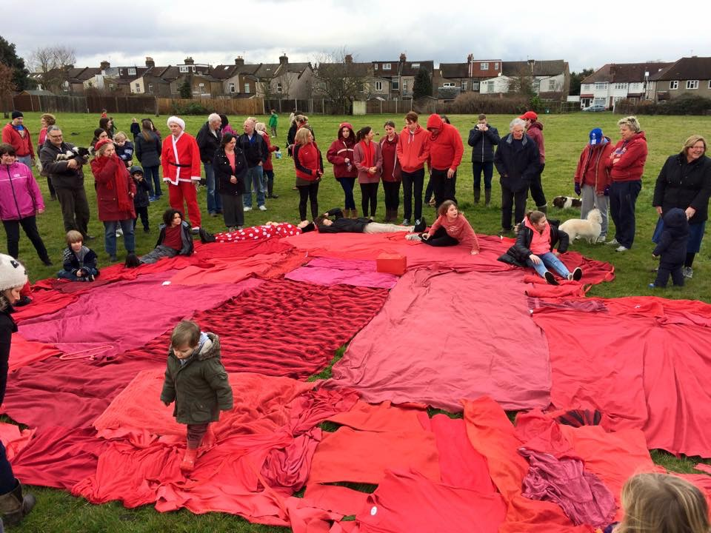
The Park is the Heart of our Community, campaign event on 14th Feb 2015.

4. History and Heritage

Havelock Rec began life as the brick pit, kiln, and brick works, for the Lord of the Manor, Mr Cole-Childs (he purchased the Lord of Manor title from the Diocese of Rochester in 1845) who “built an extensive brickworks on the southern boundary of his estate”. The deepest part of the workings was a pit, possibly 60’ deep at the Eastern side. There are more details and photographs on the website at (http://friendsofhavelockrec.org/local-history-brickfield-and-area/#hist) and also contributions from local residents who remember it during, or not long after, WW2 (http://friendsofhavelockrec.org/oral-history-of-the-local-area/).

For management purposes, it is useful to know that the original London clay is present for in a 10m deep strip on the southern boundary of the park. This original London Clay is the better substrate for planting on. The remainder of the park is turfed-over rubble, rubbish, and the left-overs from the gas works (who owned it). There are some photographs of it as a working pit from 1921, taken by a British Geological Survey geologist, also at http://friendsofhavelockrec.org/photos-working-brick-pit/, British Gas then passed ownership of it to the council, and their agent Mr McIntosh, grassed it over, so it was opened to the public in 1952.
Some issues to be aware of:
1960s – The council had to compensate a Millwall FC player from injury from glass emerging from the landfill in the park.
1990s – the Liberal Democrat council proposed to create a Havelock Wood (!) over the entire park by not mowing any longer. Their administration ended with a by-election in this ward, where the residents all demanded that their park should be mowed again.
2004 nursery doubled in size (for the 2nd time), and illegally fenced in the car park (the fencing in the planning application did not include the car park).
2008 nursery applied to expand their lease/area to 1/3 of the park, but action by local residents meant that this was refused.
2015. As previously mentioned, the park was put forward to the Education Funding Agency as the site to build a new school (approx. 900 pupils) by the council’s Development and Regeneration Officer.
Though the park is modest, it is much valued by the local residents, who formed the Friends of Havelock Rec when it was threatened in 2015 (see right). Since then, the park has been better cared for, and is cleaner.

5. Social Links

The park is used for events held by the Friends, most years this includes a Big Lunch and a Bug and Bird activity day. As a proportion of the committee also manage Whitehall Rec, we are limited to the summer weekends (when school holidays are also considered) that events can be held, as they can’t coincide with major Whitehall events like Apple Day and the beer festival. There is a great deal of benefit to the Whitehall Rec connection as much expertise and equipment is shared.
The park is also used by Gateway to All Sports Project (GASP) to hold classes and after school activities.
The friends are hoping to develop links with Raglan Road school. We feel that the park has much to offer as a place to study and play. In particular, they would like to see the annual sports day held in the field instead of a concrete playground.

6. Summary of improvements since 2015

When the park’s friends group was formed in 2015, the park was not well maintained and gave the incorrect appearance of being un-loved. This section is about the changes to the park since then.

6.1 Improvements on the Ground

In February 2015, Dr Judy Johns did a biodiversity report on the park, and made some recommendations, which the friends have attended to, though some proposals had to be amended to reflect other things that have come to light since. The full report is in #A3: Biodiversity Report from 2015:
Temporary notice boards were placed at the entrances, having gained special permission, in spring 2015.
In 2017, Idverde started to litter pick it a few times a week in the early morning. This has improved the park and we find that a tidy park discourages dog owners from not picking up.
Trees (broadleaf) were planted to replace gaps in the perimeter planting, but those over the rubble infill of the brick pit, have suffered in dry spell the park suffers from every June, so many are struggling and a few have died. The ones behind the houses on the Havelock side of the Park, have been watered by residents with gates onto the park, and have mostly thrived.
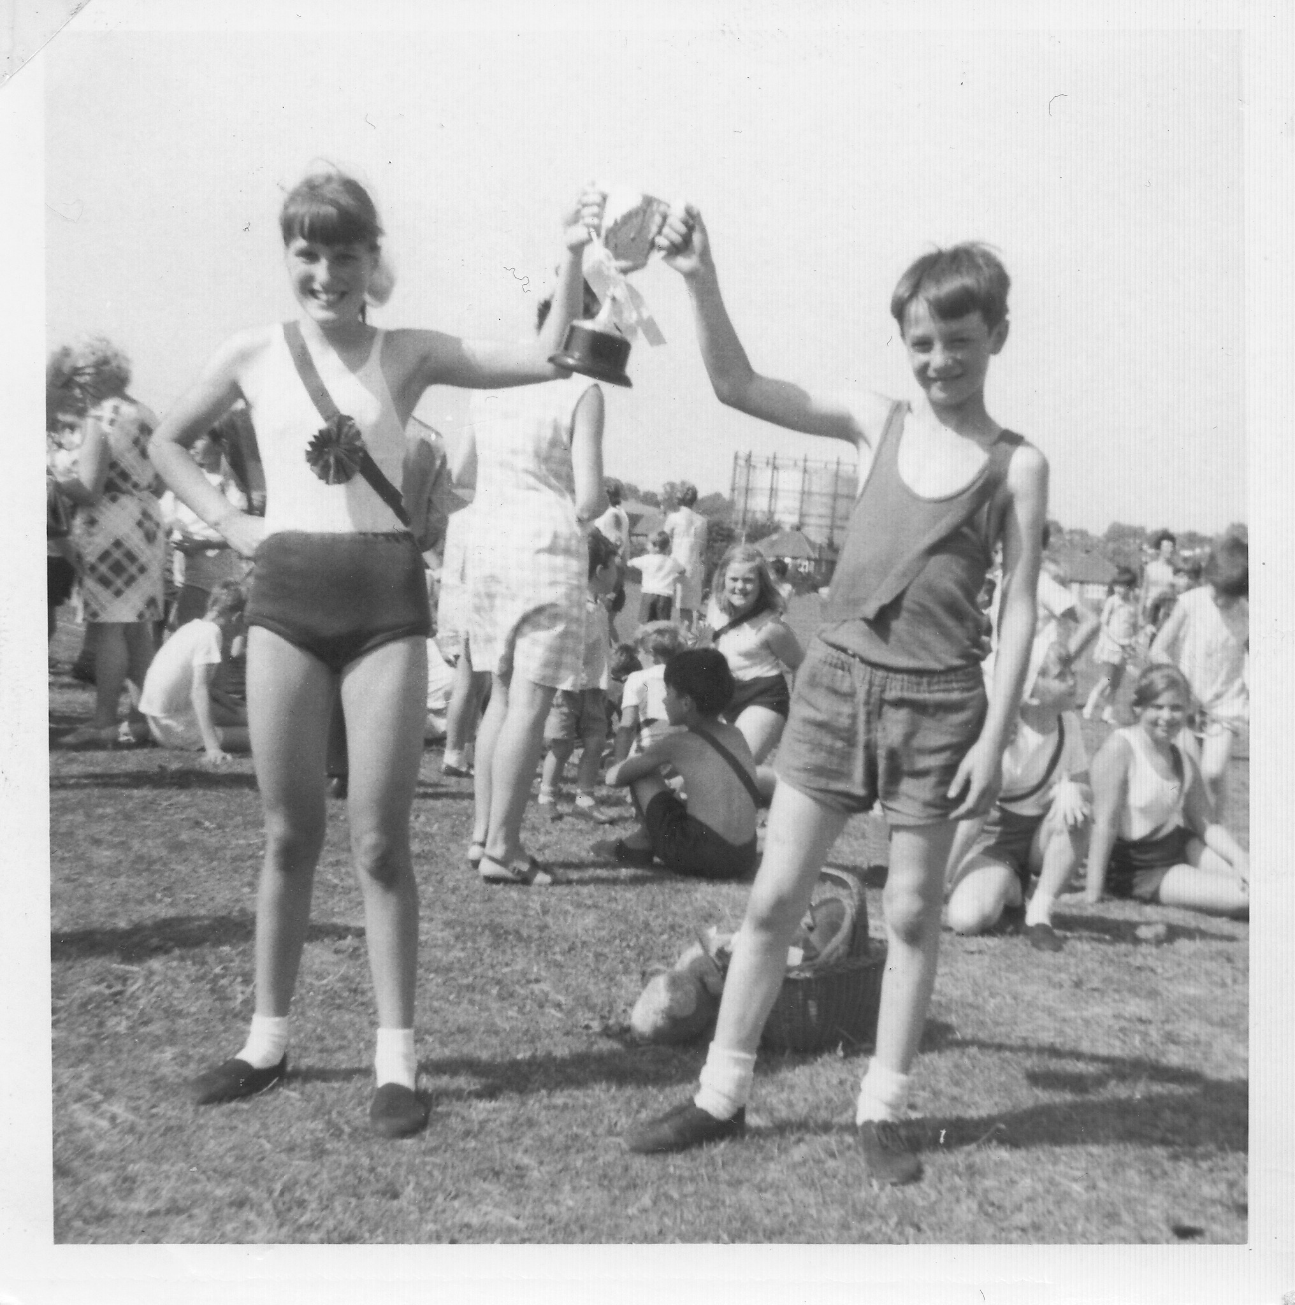
Raglan Road sports day on Havelock Rec in 1969.
Some spare Scots Pine trees were planted the SE corner, forming a pleasant grove at the end of the hedge, in the winter of 2017. At the time of writing, after re-staking in 2018, they are alive.
The friends have been planting a hedge along the chain link fence, in winters of 2015/6/7 – these whips tend to be thinned out in the June dry-out so this area is getting a natural dispersed layout with a variety of species, provided (and thanks to) Evo Energy.
In spring 2018 it was finally agreed to leave an area of longer grass to provide a meadow area and improve bio-diversity. This meadow area changed (from the one recommended in the Biodiversity Report, Appendix A3). It is narrower against the northern chain-link-fence boundary, due to wanting benches to be attractive/accessible) and added around the trees on the southern boundary because that was the only part with the original London Clay underneath.
Dogwood (coloured) was planted at Homesdale road entrance, though there are gaps that need replacing.
In 2018 the friends restored the Canadian High commission plaque in memory of Patricia Ann Drennan that was removed when the nursery expanded.

6.2 Improvements with the Park’s status
When it was announced that a school would be built on the park, the friends applied for Town Green legal status for the park, but the council refused to register it.

However, the park was registered as a Local Community Asset (number 18 for Bromley) under the Local Government Act.

In 2016 it became possible to register parks (among other sites) as Green Spaces and the friends successfully applied for this.

7. Policy and Strategic Context
Friends of Havelock Recreation Ground – our Purpose and Objectives are:
1. Maintain the open vistas and big skies of the park
2. The park should be about freedom not restriction. Let the wide-open spaces be used by the community in ways that they desire.
3. Try and increase the natural diversity of the park, but not detracting from points 1 & 2
4. Make the park a more rewarding experience for our visitors
5. Work under the supervision of the council* to maintain the park in good order and to try and achieve the objectives highlighted in the previous points

*the professional officers of the London Borough of Bromley (LBB)

The mission statement of the Friends is quite simple, because most of our users surveyed wanted it to stay more-or-less the same (See survey result in Appendix A1)
See Appendix A7 (with thanks to Idverde for drawing this up in their template) for the national planning policy framework. Extracts from the draft local plan and 2016 Building A Better Bromley have been included in this appendix.
The council, their contractor Idverde and Friends groups / Friends Forum should work together to further enhance the vision for the park linked to future aims.

8. Plans to improve the park:

The following improvements to the park, have been carefully considered by the (Friends of Havelock Rec) committee, and plotted on the following map of the park:

- Improvement of the park entrance from Homesdale Road. At present it is some broken railings, which gives the wrong impression of how loved the park is. In two parts: (1) planting coloured dogwood, with foxgloves and daffodil/spring bulbs, down one side. (2) adding a chicane of railway sleeper beds in place of the railing. Funding has been applied for (August 2018) from Greggs  - Replace cheap plywood on temporary notice boards. The Homesdale entrance is done, but the scorching faded and the lettering will be redone in a darker colour  - We like Stephen Lofting (Bromley Biodiversity Advisor) proposal of a bog garden in the waterlogged area just to the east of the container.  - Audio Trail (with noticeboard) to inform users of the local heritage, using some of the excellent memories older residents have contributed.  - Litter bins. Currently they are provided at the entrances and are inadequate and inconvenient. We want covered fox proof bins, reducing mess from animals and dumping of domestic waste. | - A circumference path, or at least improvements between Homesdale Road and Havelock Road (aka Marlborough Avenue) entrances where the London Clay substrate makes it boggy over winter.  - Logs / Stumps / bumps to provide natural play features. Logs have successfully been added to Whitehall Rec.  - Picnic and sitting benches. Add a picnic bench, close to the dip, where parents could watch their children play (but not so close as to impede access). Add 2 or more little sitting benches on the south side.  - Human Sundial to commemorate our brick making heritage and summer time introduction (with noticeboard)  - Smaller works: Bat Boxes, Bird Boxes, and climbing plants and bug hotel on side of the container  - Add a [Local Park] road sign on Homesdale Road, as the park is not visible from any of the surrounding roads.  - Native species hedge against the north chain-link fence, and meadow in front of this and in the triangle south of the Homesdale to Havelock road entrances.

8.1 First cut at timescales for these proposals:

A plan of the timeline for the Friend’s proposals, and completing the work already started.
It is possible that a fitness equipment/trail could be added, as there appears to be funding for it under Healthy Lifestyles Schemes, and it might be able to include a perimeter path.
The container café idea is not included as there isn’t anyone with spare time to pursue the idea, it would require considerable effort to coordinate volunteers to man.
If either of these schemes materialise then the Friends will see if it’s possible amend the Management Plan.

Sign-off: | 2020 | 2020 |  |  | 2021 |  | n/a |  | n/a | n/a | n/a | n/a |  | n/a
Complete: | 2020 | 2022 |  |  | 2021 | Dec 2019 | Dec 2018 |  | 2019 | 2020 | 2020 | ? |  | 2024
Commencing | Nov 2015 | 2019 | 2020? | 2026? | 2021 | Jun 2019 | Jan 2018 |  | 2019 | 2017 | 2015 | ? | ? | 2020?
Funding applied / receive | (donated) | From Gregs by Emma Sep18; awarding Dec 18 | TFL | ? | To be raised | To be raised | donation | n/a | n/a | n/a | n/a | ? |  | ?
Design/Proposal Drawn UP | Plan approved by ideverde / Stephen thickener Aug 15. | n/a as already placed in ward parks | n/a | n/a | n/a | Outline approved Jul18, details in progress | n/a | n/a | n/a | n/a | n/a | ? | ? | tba | n/a
Details | Clumps of ornemtal dogwood down one side of the entrance, with some foxgloves and lots of spring/daffodil bulbs | Two railway sleeper raised beds placed in a chicane. Same as Green Gym have put in other town centre parks | A path with a surface that push- and wheel-chairs can use from Homesdale to Haevlock entrances | Extend the above path around the remaining perimeter | Picnic table installed near the Homesdale end of the dip. | Brick pillars arranged so that a person standing on a central paving stone can tell the time from their shadow. 14 plinths. 1 noticeboard. I lettered slab. | Replace the plywood on the temporary noticeboards put up during the campaign – scorching faded on first one | Logs / Stumps / Bumps | Small Eco improvements: Bat Boxes, Bird Boxes, climbing plants & Bug hotel on container, | Simple homemade benches of the same pattern added in 2017 | Native species hedge on north boundary against chain link fence. Meadows by hedge and in triangle formed on south side of line from Homedale to Havelock entrances. | There is not enough litter bins, and they are only on the exits of the park. We want them by the nursery benches and picnic table. | Pointing to the park from Homesdale Road | Bog garden in the waterlogged area to the east of our container. Bound on north with 2 benches | ??
Rational | It was a barren, windswept entrance giving an unloved look | The broken railings are giving the wrong impression that the park is not loved | Essential to make the park accessible to pushchair and mobility challenged users. | Open the park up for disabled users. | Improvement for parents wanting a place to snack / chat whilst watching small children. | Provide a park focus (for family outings, commemorate the brick making heritage | Looking loved. Inform users about events and discourage dog fouling. | unstructured play space for children encouraging outdoor play | Simple things to improve biodiversity | Providing + encouraging the infirm to use the park | Improve biodiversity and some visual diversity for park users | Need more bins. Need fox proof bins. | Compensate for park not being visible from road | Leverage dampness and biodiversity | Advantages to introducing children to their park at an early age foster ownership and reduces vandalism. Raise park profile in the community.
Item | Homesdale Entrance  - Dogwood planting, with foxgloves and bulbs | Homesdale Entrance  - Sleeper raised bed chicane | Circumference Path  - Boggy section from Homesdale to Havelock entrances. | Circumference Path  - remainder | Picnic bench(s) | Human Sundial | Noticeboards at entrances | provide natural play features | Small Eco improvements: | Sitting benches | Native species hedge and Meadows on north and south sides. | More & better litter bins | Add [Local Park road sign | Bog garden | Develop link s with Raglan School
Objective | Welcoming Park | Welcoming Park | Welcoming Park | Welcoming Park | Healthy Park | Healthy Park | Welcoming Park | Healthy Park | Sustainable Park | Healthy Park | Sustainable Park | Clean Park | Welcoming Park | Biodiversity | Healthy Park

8.2 SWOT - SMART Objectives
Here’s the result of our SWOT analysis for the park:
(SWOT - below - SMART Specific, Measurable, Achievable, Realistic and Timebound)
Strengths | Weaknesses | Opportunities | Threats
- Open space  - Trees planted around perimeter 2017  - The mown area provides a good place to relax and sit  - Park has popular events run by the Friends of Havelock Recreation ground  - Good transport links  - Hedge and meadow areas being developed have improved biodiversity | - Inaccessible to the disabled or local infirm residents that need to access by car, as there is no non-zoned parking places.  - No toilet facilities  - No refreshment facilities  - Limited seating  - Problems with dog fouling  - Has been ASB in summer months  - Noticeboards are temporary and replacement needs work  - Some entrances are not welcoming | - Create stronger links with other community groups  - Container Café  - Develop and widen sports facilities in the park, eg Outdoor gym  - Develop a range of wild life Habitats  - More nature days  - Improve signage  - Develop links with Raglan School  - Plant more trees  - Plant more spring bulbs  - Establish wet/bog plant area | - Anti social behavior  - Development (venerable as only non-ornamental park in ward)  - Underfunding/  lack of investment  - Limited number of active residents from the community

8.3 Considerations arising from talking to Park users
“While protecting a park from outside intrusions, managers must also preserve it from abuses within. It is important that these demands be weighed against the park’s dominant character and overall use preferences…
The purpose of good park planning is to place all parks in a harmonious relationship”

Some differences of opinion that came to light from the surveying:
- Some remonstrations between parents and dog walkers, where children find dogs scary and dogs find children scary
- Disagreements as to whether a dog off the lead is allowed or under control
- Concern that a perimeter path might allow children with bikes and scooters to ‘push’ less able people off the path and frighten nervous dogs into running/barking.
Note: in this park, the received wisdom about having gates from resident’s gardens into the park, is the opposite of our findings: rubbish is tipped by (renting) people who have unkempt fences and rough vegetation areas behind their properties; whereas those with gates take a proprietary interest in the field and are more involved. None of them have dumped rubbish behind their gates.
On discussion, a few of the more elderly park users wanted some car parking that is not in the permit zone (because we are on the edge of a zone, and some people two roads away are in a different zone). They felt that by the time they’d walked from their house, they were too tired to then actually enjoy the park. One of these had conflict with the nursery manager on this issue. The nursery fenced off the park’s car park in 2002/4 without consultation or notice (the planning permission was entitled ‘Single Storey Extension’) to the residents (and contrary to their planning permission at https://searchapplications.bromley.gov.uk/online-applications/applicationDetails.do?activeTab=documents&keyVal=H6HW50BTS0000)

8.4 Supporting data for these proposals:

The things that have been identified as wanted by the park users surveyed:
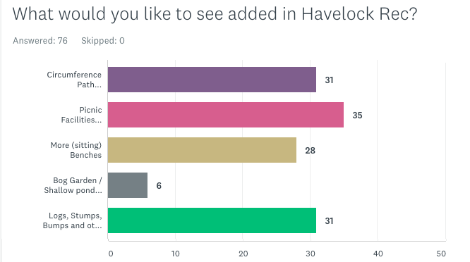
In the free-text entry:
“It is the combination of the character of the green space and the needs and expectations of the wider community, including people who do not use the green space, that informs every stage of the development of the management plan”
- BBQ area
- Childrens Playground – this can be ruled out on costs grounds (and there is one in Whitehall Rec and another in Norman Park) and because a number of respondents specifically said they didn’t want it in the ‘what do you particularly not want to see in the park’ free entry text field.
- Outdoor gym / pull-up bars
Other ideas:
- Human sundial bricks (to make a feature in the park to focus outings and commemorate the brick making heritage)
- Audio trail – this is of necessity waiting for the oral history work to be recorded.
- Adding logs and bumps natural features which could enhance the unstructured play opportunities
- Development of the Homesdale Road entrance to replace the broken railing with railway sleeper boxes
- Planting trees behind the ‘pikey posts’ to improve their appearance, and/or railway sleeper raised beds
- Adding native species climbing flowers to the friend’s storage container.

We need more bins, and ones that are fox proof.

Practical Management Plan for the Year
Paying attention to -
- Growing seasons
- Wildlife disruption

Key:
LBB - London Borough of Bromley
IDV - Idverde
FOHR - Friends of Havelock Recreation Ground

9. Site Management

Please see the idverde statement in appendix A6.
Other parks in the town ward have bi-monthly meetings with their park officer. This sounds like it would be a useful thing to have for our park too; perhaps every six months?

Appendices:

#A1. Analysis of Survey Results:
#A2. Friends of Havelock Rec Vision Statement:
#A3: Biodiversity Report from 2015:
#A4. Analysis of 2011 census data from Streetcheck:
#A5: Example of a joint monitoring inspection sheet.
#A6. iDverde’s management procedures & plan:
#A7 - Policy and Strategic Context
#A8 - The Park and Local Green-space Deficiency
#A9 - Entry for Havelock Rec in Draft Local Plan
#A10 - iDverde statement on park users and staff
#A11 - iDverde's Sustainability policy
#A12 - IDverde's Foreword & Introductions

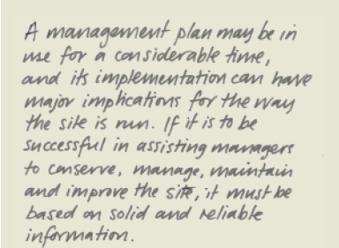

Appendix A1: Analysis of Survey Results:

Most people wanted the options presented, apart from the bog garden which was not especially popular. These options were: circumference all-weather path (to improve accessibility), Picnic benches, more sitting benches, and logs-stumps-natural-play-structures.
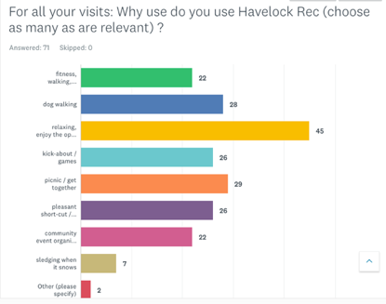
The suggestions in the free text with the highest number of mentions was “just as it is” (8 out of 44 / 18%), children’s playground (8 out of 44 / 18%) and outdoor gym equipment (6 out of 44 / 13%). Six people mentioned an-all-weather-perimeter path despite it being in the check boxes of the previous question. Other notable mentions are fox-proof bins, and proper gates on the Mornington and Homesdale Road entrances.
The survey response sheets were scanned and entered on Survey Monkey, so that the question could be made available on the web to non-park users.
The resulting charts:
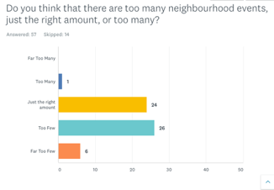 | 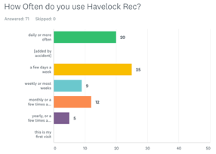 | 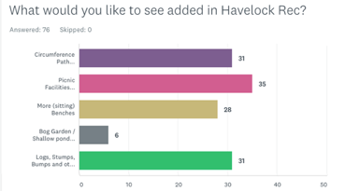

And the catchment bars shown on a map:

The full text answers to ‘What would you particularly like in the park?”
Excel Iindex | Data entry time | Comment
69 | 8/16/2018 7:54 AM | Walkways
67 | 8/16/2018 7:50 AM | Like it as it is
65 | 08/10/2018 22:51 | More long grass patches
64 | 08/10/2018 22:49 | I like it just as it is
63 | 08/10/2018 22:47 | Picnic benches would be great
62 | 08/10/2018 22:45 | Longer grass in patches; more wildflowers for bees & wildlife
60 | 08/10/2018 22:40 | More trees
59 | 08/10/2018 22:26 | Just as it is
58 | 8/10/2018 10:23 PM | Fitness Bars – Calisthenics
57 | 08/10/2018 22:20 | Pathway, flowers, obstacles
56 | 08/10/2018 22:17 | Raglan Road use it for Sports Day instead of concrete playground
55 | 08/10/2018 22:06 | Like it as it is
54 | 43381.91875 | A festival
52 | 08/10/2018 21:50 | Natural play area with trees
51 | 08/10/2018 21:46 | Pull-up bars
50 | 8/10/2018 9:44 PM | Festival or Fete
49 | 8/9/2018 5:43 PM | Landscaping (like the flowerbeds in Whitehall Rec)
48 | 8/9/2018 5:39 PM | Childrens Play Area
47 | 8/9/2018 5:36 PM | Left as it is
46 | 8/9/2018 5:36 PM | Gate on [Homesdale and Mornington Av] Entrances
45 | 08/09/2018 17:36 | All weather path, more bins / doggy bins, music (we like a band)
42 | 8/8/2018 7:46 PM | All weather path
41 | 8/8/2018 7:43 PM | Childrens playground
40 | 08/08/2018 19:41 | BBQ area and football posts
39 | 08/08/2018 19:40 | Fox proof bins. Tennis courts. Zip Wire.
38 | 08/08/2018 19:11 | I like it now
36 | 08/08/2018 19:03 | A refreshments hut manned by volunteers. Solar lighting.
35 | 08/08/2018 19:00 | I like it the way it is but with the recovery of the car park
33 | 08/08/2018 18:41 | Fun things
27 | 08/08/2018 13:33 | Playground
24 | 8/8/2018 1:23 PM | Small Playground
23 | 8/8/2018 1:21 PM | Playground for the kids, Information boards
22 | 8/8/2018 1:19 PM | Playground
19 | 8/8/2018 12:59 PM | Outdoor gym equipment
16 | 8/8/2018 12:43 PM | Litter bins and toilets
15 | 8/8/2018 12:39 PM | Shaded areas, Events for families
12 | 08/07/2018 18:47 | The whole point of Havelock Rec is that it's a decent size open space. It does not need nor want 'developing'. The point is openness. The point is space. This allows for wonder, imagination and freedom... benches allow us to appreciate it.
10 | 8/7/2018 6:38 PM | Some play equipment for the children or excerise equipment that they seem to be placing in parks now :)
9 | 8/7/2018 6:36 PM | An adventure playground using wood. One or two goal posts boys locally always playing footie. PIcnic area for those people who live in the flats and I think us residents would use.
8 | 8/7/2018 6:33 PM | Bar b que area, and outdoors fitness area
6 | 8/7/2018 6:20 PM | A pathway from one side to the other. Bark maybe to keep it natural
5 | 8/7/2018 6:18 PM | A small fenced in play area for the local children
2 | 8/7/2018 6:00 PM | suggest we get funding for outdoor gym equipment
1 | 08/06/2018 22:41 | An all weather perimeter trail for runners and buggies. Could have distance markers for the runners (like Dulwich Park) and make it possible to walk around it after rain with a buggy.
44 |  | number entries with text
 |  | Percentages

So the suggestions in the free text with the highest number of mentions was “just as it is” (8 out of 44 / 18%), children’s playground (8 out of 44 / 18%) and outdoor gym equipment (6 out of 44 / 13%). Six people mentioned an-all-weather-perimeter path despite it being in the options. Other notable mentions are fox-proof bins, and proper gates on the Mornington and Homesdale Road entrances.

The full text answers to ‘What would you particularly not want to see in the park?”

Excel ID | Data Entry Time | Showing 28 responses
69 | 08/10/2018 07:51 | Bromley Beacon Boys intimidating as they shout at you; they set their PE area up so close to the entrance they're in the way
1 | 08/10/2018 22:51 | More Buildings
1 | 08/10/2018 22:45 | Buildings / Development
1 | 08/10/2018 22:26 | Build Buildings
1 | 08/10/2018 22:20 | Buildings on the field
1 | 08/10/2018 22:17 | formal playground (as there's one at Whitehall Rec)
1 | 08/10/2018 22:06 | Any building on the land or cutting back the land for other use
1 | 08/10/2018 22:03 | Dog shit
1 | 08/10/2018 21:56 | A school
1 | 08/10/2018 21:44 | Like it as it is
1 | 08/08/2018 20:02 | Any Buildings
1 | 08/08/2018 19:59 | As it is, no buildings
1 | 08/08/2018 19:46 | Playground
1 | 08/08/2018 19:43 | Any big structures or anything that encourages teenagers
1 | 08/08/2018 19:41 | Pikeys
1 | 08/08/2018 19:40 | A school
1 | 08/08/2018 19:03 | Not a children's playground (cited conflict with dog walkers)
1 | 08/08/2018 18:48 | Buildings
1 | 08/08/2018 18:41 | Buildings
1 | 08/08/2018 18:37 | Smoke Shelter
1 | 08/08/2018 18:33 | Buildings
1 | 08/08/2018 13:34 | Houses
1 | 08/08/2018 13:33 | Construction
1 | 08/08/2018 13:19 | Cycling path
1 | 08/08/2018 13:14 | Buildings erected
1 | 08/08/2018 12:57 | Any buildings erected
1 | 08/08/2018 12:43 | Dog Mess
1 | 08/08/2018 12:39 | Being too built up
28 |  | count of responses
40.5 |  | of total responses

Despite the park not being under threat, 60% of respondents cited ‘buildings’ or ‘development’ as something they don’t want for the park.

Appendix A2: Friends of Havelock Rec Vision Statement:

Please see this statement, and other documents, on our site: http://friendsofhavelockrec.org/documents/
1. Maintain the open vistas and big skies of the park
2. The park should be about freedom not restriction. Let the wide open spaces be used by the community in ways that they desire.
3. Try and increase the natural diversity of the park, but not detracting from points 1 & 2
4. Make the park a more rewarding experience for our visitors
5. Work under the supervision of the council* to maintain the park in good order and to try and achieve the objectives highlighted in the previous points

*the professional officers of the London Borough of Bromley (LBB)

Appendix A3: Biodiversity Report from 2015:

Havelock Recreation Ground: Biodiversity Report and Suggestions.
6th February 2015
This small recreation ground covers about 9 acres about 1km south-east of Bromley Town Centre. It is surrounded by housing and consists mainly of a level area of short amenity grassland with about 3? mature specimen trees in the eastern corner. In the northern part of the site some smaller trees grow on a slope which provides some shelter. There is little scrub cover, most of the gardens backing onto the recreation ground are fenced. One boundary has wire netting fencing. Currently there is little room for wildlife here, but sympathetic management with some planting of locally provenanced native species would improve this situation and help LBB fulfil its biodiversity duty under the NERC Act 2006, Section 40 of which states, ‘Every public authority must, in exercising its functions, have regard, so far as is consistent with the proper exercise of those functions, to the purpose of conserving biodiversity .....Conserving biodiversity includes, in relation to a living organism or type of habitat, restoring or enhancing a population or habitat.’ Enhanced biodiversity would also provide an important educational resource for children.
Suggestions for enhancing the habitats at Havelock Recreation Ground for biodiversity are as follows:
- Plant a hedgerow of mixed, native, locally provenanced (at least from south-east England) bare root whips against the wire-netting fence where there is plenty of light for young plants to thrive. They should be planted in a staggered double row 5-6 plants /metre between November and March. Suggested species: Hawthorn: white flowers in spring, red berries in autumn for birds and important for a large number of invertebrates (food for birds and bats). Hazel: catkins early in spring, nuts in autumn, vigorous and can be coppiced. Field Maple: golden yellow leaves in autumn Dogwood: white flowers after hawthorn, black berries in autumn Guelder Rose: very attractive white flowers in late spring, red berries in autumn and stunning red/orange autumn foliage Alder buckthorn: white flowers, berries go from green to red to black. Foliage important for caterpillars of brimstone butterflies Beech: brown leaves retained over winter The hedgerow will support a wide range of invertebrates: the more mixed the plant species the greater the invertebrate variety. These can be found by children doing mini-beast hunts. In the long-term the hedgerow will provide nesting sites for birds and the base will provide shelter for small mammals such as hedgehogs, shrews, voles and possibly slow worms.
- The hedgerow should link to the area of scrub in the north-east corner of the site, at the end of the ‘valley’ area. Bramble scrub is very important for a wide range of invertebrates, birds and small mammals providing them with food, nesting sites and shelter. Nesting sites in bramble will be safer for birds than the hedgerow for a number of years until the hedge has grown sufficiently thick. The scrub will need to be cut back a bit in autumn to prevent it invading the meadow, but plenty should be left. Encourage people to come and pick blackberries - in trying to reach the best ones, the edges of the bramble scrub may be pushed back enough!
- Leave a wide margin of grass bordering new hedgerow uncut over summer. Cut & clear away clippings in August/September annually. Suggested width of ‘hay meadow’ to extend beyond the existing recently planted line of trees (? 10-20 metres or more). This will provide habitat for a different set of invertebrates compared to the hedgerow and provide opportunities for children to see different species e.g. grasshoppers and the butterflies whose caterpillars eat grass such as skippers, meadow brown, gatekeepers etc. By siting the wildflower/hay meadow here it may help prevent damage to the new hedge by inappropriate mowing. It must be stressed to any contractor that they should not cut grass within 1metre of the new hedge.
4. Plant understorey of hazel, dogwood, hawthorn etc under mature trees to give this area a better structure supporting more invertebrate species and therefore more birds & bats.
Other things to consider may be having a second area of ‘wildflower/hay meadow and/or planting an area with orchard trees such as apples, pears, damson and wild cherry.
Judith John 6th Feb 2015

Local Businesses contacted during the drawing up of this plan:
Little Learners Early Years Centre (though we call it the Nursery) Havelock Pavilion – email 1st October 2018 to littlelearnerseyc@yahoo.co.uk.
Bromley Car Audio – ditto info@bromleycaraudio.com50D Homesdale Rd, Bromley BR2 9LD
Don Giovanni. ADDRESS. 57-59 Homesdale Road Bromley, Bromley, BR2 9LB on info@dongiovannirestaurant.co.uk
Beacon Academy Old Homesdale Road, Bromley office@bromleybeaconacademy.org.uk
Homesdale Motors, Old Homesdale Road, via contact form
Esteema Financial Advise, 40 Homesdale Road, at ambrish@esteemagroup.com.
Madisons, Homesdale Road, at info@madisonsrestaurant.co.uk

Appendix A4: Analysis of 2011 census data from Streetcheck:

NOTE: this data is 8 years old and less accurate than it might be. On Homesdale Road, Iconia House, Azzura House, Garrard House and Rosing Apartments, were all offices, as was Berkeley House (formerly Archers court), opposite. The Dripping Tap (Woodham Apartments) was a shop and flats at Kentway Court on the Hayes Lane corner was a single house. These are now all flats, so have probably added 200 dwellings in the immediate area with no outdoor space (who might have more need of a local greenspace than properties with gardens).
The Areas:

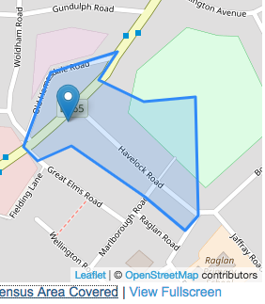 | 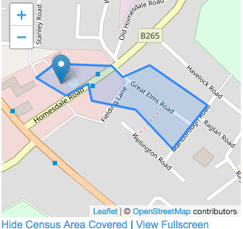
BR2 9NY, BR2 9NZ, BR2 9LD | BR2 9LY
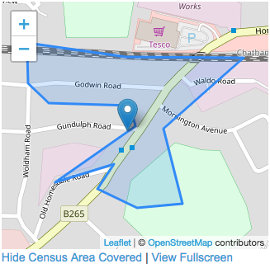 | 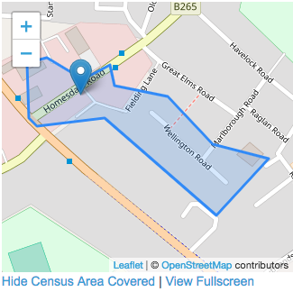
BR2 9LE | BR2 9NB

My Summaries:
These are my conclusions from the collated data:
Housing Type: | Flats make up the largest type at 35% (which will increase at the next census), followed by semi at 26% and terrace at 22%
Housing Tenure | 40% are mortgaged, and 32% rented (LBB never had much council housing so that includes 6% social rented)
Social Grade: | Streetcheck's analysis tool says that 40% have "" and 28% management/professional work, with 12% on the 'lowest grade' of unemployed/ unskilled workers.
Education / Qualifications | Slightly higher proportion than average are well educated (36% with degrees or above compared national average 34%) whist 22% have no GCSEs or 'other' (eg School Certificate)
Ethnic Origins | The area is a bit more diverse (82% white) than average for England (86%) with the largest non-white groups being Mixed (4%) and Black African (4%)
Country of Birth | Nearly 80% of residents were born in England with almost 5% coming from the EU and 9% from 'other'.

The Analysis on Streetcheck:
Summary of what the Streetcheck analysis is for each survey area (these were used as a start point):
question | BR2 9NY | BR2 9LY | BR2 9LE | BR2 9NB
housing type: | The area containing Havelock Road, Bromley consists predominantly of terraced housing, which is common in suburban and inner-city areas | The area containing Homesdale Road, Bromley consists predominantly of flats, which is common in inner cities, student neighbourhoods and poorer suburban settings. | This area contains a mixture of housing types, as detailed below. No single type of dwelling accounts for more than 50% of the dwellings. | This area contains a mixture of housing types, as detailed below. No single type of dwelling accounts for more than 50% of the dwellings.
housing tenure: | This area consists predominantly of housing where the property is being repaid through a mortgage arrangement. The national average is just under 33%, while in this area it represents 50% of housing spaces. | The area containing Homesdale Road, Bromley contains a higher than average level of rented housing (excluding social housing) - 47% of household spaces. This contrasts with the national average of just over 16%. | This area contains a mixture of housing tenures, as detailed below | The area containing Homesdale Road, Bromley contains a higher than average level of rented housing (excluding social housing) - 31% of household spaces.
Ethnic Group | As whole, the UK population claims itself as approximately 86% white, with this area being 80% white. As a country with a diverse population, the UK is home to other sizable ethnic groups, with mixed ethnicity (2.1%), Indian (2.4%) and Pakistani (1.9%) being the largest groups reported. | As whole, the UK population claims itself as approximately 86% white, with this area being 86% white. | As whole, the UK population claims itself as approximately 86% white, with this area being 84% white. | As whole, the UK population claims itself as approximately 86% white, with this area being 81% white.

Streetcheck explanation of these survey categories:
Social Grade | Social Grade approximations are derived from an algorithm created by the Market Research Society. The figures shown are per-household rather than individual - more specifically, the job title and employer of. the "household reference person" is used, analogous to what traditionally was called the head of the household Only household reference persons between the ages of 16-64 are included.
Education & Qualifications | At the time of the 2011 census, across the UK 22.9% of residents had no qualification, 13.2% had 1-4 GCSEs, 15.2% had 5+ GCSEs and 1-2 A/AS-Levels, 12.3% had 2+ A-Levels, 27.1% had a degree (or similar), and 3.6% had an apprenticeship.  The qualification levels are based on current qualification names. The former Ordinary Levels (O-Levels) and CSEs will be included in the GCSE figures, and Higher School Certificates (HSCs) will be counted as A Levels.
Country of Birth | At the time of the 2011 census, approximately 83.5% of the resident population of England were born in England. The other groups were 1% Welsh, 1.35% Scottish, 0.4% Northern Irish, 0.75% from the Republic of Ireland, 3.75% from other European Union countries, and 9.4% from outside of Europe, with the remainder not stated.

The data:
Area |  | BR2 9NZ | BR2 9LY | BR2 9LE | BR2 9NB | Area Total | Percen tage
Housing type | Detached | 3 | 9 | 4 | 2 | 18 | 3.57
 | Semi-Detached | 16 | 16 | 51 | 49 | 132 | 26.19
 | Terraced | 28 | 17 | 46 | 18 | 109 | 21.63
 | Flat (Purpose-Built) | 18 | 64 | 18 | 55 | 155 | 30.75
 | Flat (Converted) | 5 | 7 | 4 | 5 | 21 | 4.17
 | Residence in Commercial Building | 11 | 0 | 2 | 4 | 17 | 3.37
 | Category Total | 133 | 113 | 125 | 133 | 504
tenure | Owned Outright | 25 | 24 | 32 | 30 | 111 | 23.82
 | Owned with Mortgage | 63 | 22 | 55 | 51 | 191 | 40.99
 | Shared Ownership | 1 | 1 | 2 | 0 | 4 | 0.86
 | Rented: Other Social | 10 | 4 | 3 | 9 | 26 | 5.58
 | Rented: Private Landlord | 22 | 46 | 16 | 40 | 124 | 26.61
 | Rented: Other | 4 | 1 | 3 | 0 | 8 | 1.72
 | Category Total | 125 | 99 | 112 | 130 | 466
social grade | AB - Higher and intermediate managerial, administrative, or professional positions | 32 | 12 | 21 | 35 | 100 | 28.65
 | C1 - Supervisory, clerical, and junior managerial/administrative/professional positions | 44 | 22 | 40 | 35 | 141 | 40.40
 | C2 - Skilled manual workers | 18 | 5 | 19 | 20 | 62 | 17.77
 | DE - Semi-skilled and unskilled manual workers; those on state benefit/unemployed, & lowest grade workers | 13 | 4 | 6 | 19 | 42 | 12.03
 | Category Total | 107 | 43 | 90 | 109 | 349
education | Degree/Professional | 80 | 44 | 55 | 96 | 275 | 36.28
 | Apprenticeship | 7 | 7 | 4 | 4 | 22 | 2.90
 | 2+ A Levels | 31 | 27 | 24 | 33 | 115 | 15.17
 | 5+ GCSEs, an A-Level or 1-2 AS Levels | 50 | 22 | 38 | 39 | 149 | 19.66
 | 1-4 GCSEs | 31 | 15 | 22 | 19 | 87 | 11.48
 | Other | 14 | 14 | 13 | 10 | 51 | 6.73
 | No GCSEs | 29 | 38 | 35 | 30 | 132 | 17.41
 | Category Total | 242 | 167 | 119 | 230 | 758
ethnic | White | 249 | 176 | 219 | 225 | 869 | 82.29
 | Mixed Ethnicity | 20 | 3 | 9 | 14 | 46 | 4.36
 | Indian | 14 | 0 | 6 | 1 | 21 | 1.99
 | Pakistani | 1 | 0 | 0 | 2 | 3 | 0.28
 | Bangladeshi | 2 | 0 | 0 | 0 | 2 | 0.19
 | Chinese | 0 | 0 | 0 | 8 | 8 | 0.76
 | Other Asian | 16 | 1 | 3 | 19 | 39 | 3.69
 | Black African | 3 | 24 | 17 | 6 | 50 | 4.73
 | Black Caribbean | 7 | 1 | 3 | 4 | 15 | 1.42
 | Other | 0 | 0 | 1 | 0 | 1 | 0.09
 | Category Total | 312 | 205 | 260 | 279 | 1056
country of birth | England | 255 | 162 | 214 | 213 | 844 | 79.92
 | Wales | 1 | 1 | 0 | 3 | 5 | 0.47
 | Scotland | 3 | 2 | 4 | 2 | 11 | 1.04
 | Northern Ireland | 1 | 2 | 0 | 3 | 6 | 0.57
 | Republic of Ireland | 2 | 0 | 6 | 1 | 9 | 0.85
 | European Union | 7 | 15 | 6 | 21 | 49 | 4.64
 | Other | 14 | 23 | 30 | 36 | 103 | 9.75
 | Category Total | 312 | 205 | 260 | 279 | 1056
The figure for the percentage of population with a degree or equivalent:
“Using Nomis, we can see that in 2012, 34.4% of the working age population of Great Britain, aged 16 to 64, achieved NVQ4+ (a degree-level or equivalent qualification or above). You can check my working if you like – here is the report I ran.” [Charlie Ball writing in The Guardian 4th June 2013 at: https://www.theguardian.com/higher-education-network/blog/2013/jun/04/higher-education-participation-data-analysis]
Streetcheck, The Guardian & Linked In Information retrieved 28/29th September 2018.
Conditions of data use:
Streetcheck makes use of several Open Data sets which are released to the public under their own copyright. The following copyright notices therefore must be repeated in this work:
- Contains Ordnance Survey data © Crown copyright and database right 2018
- Contains Royal Mail data © Royal Mail copyright and database right 2018
- Contains National Statistics data © Crown copyright and database right 2018
- Contains NRS data © Crown copyright and database right 2018 (for Scottish records)
Contains HM Land Registry data © Crown copyright and database right 2018. Streetcheck does not need to be contacted for this use of their data. More information on the Open Government Licence can be found here.

Appendix A5: Example of a joint monitoring inspection sheet.

[ Get from Jeff/Town Centre Parks Friends ]

Appendix A6. iDverde’s management procedures & plan:

(annotated by Kerry Hood as some of these statements don’t apply to our park)
Grounds Maintenance is more than just cutting the grass and emptying the bins. Ward based teams ensure operatives gain a deep understanding of their area and how its community functions. It creates a sense of pride, ownership and the ability to make swift decisions in changing conditions.
Litter and other small amount of waste or harmful material, such as broken glass and other detritus is observed and dealt with each morning as part of the site inspection and other visits are made during the day / week as required to ensure compliance with the contract specification. Litter is picked several times a week, when the bins are emptied (there is not detailed inspection - kerry)
Vandalism, fly tipping and other damage to the park or property within is dealt firmly with legislation be applied as deemed appropriate and to the full extent of the law whether that be as criminal damage or via Bromley’s internal enforcement team.
Policies and procedures were conceived at the time of outsourcing of the service and are reviewed and update jointly with the Council and other contractors to maintain levels of service and accountability. Please refer to the Grounds Maintenance Specification document, available on request.
Joint monitoring
Joint Monitoring is where a Neighbourhood Officer from the London Borough of Bromley goes around the site with an idverde supervisor to agree quality of work done taken from a random list.
Fly-tipping procedure
Any rubbish dumped in a park or green space that is less than 2 cubic meters and weighs less than two tonne in total we will attempt to remove as soon as is practical. Anything larger or heavier is referred to Bromley’s waste contractor. Burnt out motorbikes and other vehicles are either removed and stored by us by a third party or we assist in removal to the road side for collection by the local authority’s contactor.
Graffiti procedure
Graffiti on non-porous surfaces, less than 210mm by 297 mm in size is dealt with as soon as is practical. Offensive graffiti is dealt with as quickly as idverde are made aware of it. Large amounts of graffiti, or graffiti that is on hard to clean surfaces, is referred to a specialist contractor, Community Clean via the appropriate neighbour team at Bromley.
Fix My Street
This is an online reporting tool for the website or smart phone. It is primarily for reporting items which are broken, dirty, damaged or dumped, and need fixing, cleaning or clearing. These include graffiti, dog fouling, potholes or street lights that don't work. It is one of many tools idverde use to ensure we are responsive to local people’s needs and desires. Small amounts of damage, for example a broken fence panel is dealt with by our infrastructure team. More substantial work, such as damage caused by an attempted break in to a pavilion, will be referred via idverde’s enquires desk to Bromley and then to an appropriate specialist contractor. https://www.fixmystreet.com/reports/Bromley
With assistance from the Council’s in house arboricultural team, idverde actively manage the trees within that space removing dead limbs, basal and epicormics growth to pruning and shaping younger trees.
The contract document prescribes what must be done to maintain standards, but local teams understand the importance of parks to the community and attend proactively to issues to avoid escalation.

Appendix A7 - Policy and Strategic Context

A7.1 - Extracts from National Planning Policy Frame work

Promote Healthy Communities
- Access to high quality open spaces and opportunities for sport and recreation can make an important contribution to the health and well-being of communities. Planning policies should be based on robust and up-to-date assessments of the needs for open space, sports and recreation facilities and opportunities for new provision. The assessments should identify specific needs and quantitative or qualitative deficits or surpluses of open space, sports and recreational facilities in the local area. Information gained from the assessments should be used to determine what open space, sports and recreational provision is required.
- Existing open space, sports and recreational buildings and land, including playing fields, should not be built on unless:
  - an assessment has been undertaken which has clearly shown the open space, buildings or land to be surplus to requirements; or
  - the loss resulting from the proposed development would be replaced by equivalent or better provision in terms of quantity and quality in a suitable location; or
  - the development is for alternative sports and recreational provision, the needs for which clearly outweigh the loss.
- Planning policies should protect and enhance public rights of way and access. Local authorities should seek opportunities to provide better facilities for users, for example by adding links to existing rights of way networks including National Trails.
- Local communities through local and neighbourhood plans should be able to identify for special protection green areas of particular importance to them. By designating land as Local Green Space local communities will be able to rule out new development other than in very special circumstances. Identifying land as Local Green Space should therefore be consistent with the local planning of sustainable development and complement investment in sufficient homes, jobs and other essential services. Local Green Spaces should only be designated when a plan is prepared or reviewed, and be capable of enduring beyond the end of the plan period.
- The Local Green Space designation will not be appropriate for most green areas or open space. The designation should only be used:
  - where the green space is in reasonably close proximity to the community it serves;
  - where the green area is demonstrably special to a local community and holds a particular local significance, for example because of its beauty, historic significance, recreational value (including as a playing eld), tranquillity or richness of its wildlife; and
  - where the green area concerned is local in character and is not an extensive tract of land.
- Local policy for managing development within a Local Green Space should be consistent with policy for Green Belts.
Extracts from https://www.gov.uk/guidance/national-planning-policy-framework/8-promoting-healthy-communities taken on 9th December, 2018.

A7.2 Applicable extracts from 2016-18 Building a Better Bromley:
For a Quality Environment we will:
- Sustain a clean, green and tidy environment through value-for-money services provided to a consistently high standard.
- Encourage further improvements in recycling and seek to reduce waste to manage costs and protect the environment.
- Encourage Residents Associations and expanding network of ‘Friends’ to contribute to parks, trees and streets management and work with ‘Snow Friends’ during winter weather.
- Use our wide-ranging enforcement and regulatory powers in a fair manner to protect people and their neighbourhoods, thereby reducing costs associated with issues such as fly-tipping.
- Identify infrastructure investment opportunities to reduce future maintenance costs associated with maintaining a high quality street scene, including roads and street furniture.
For a Healthy Bromley we will:
- Work with health partners and focus on areas identified within the Health & Wellbeing strategy in improving health and delivering Public Health outcomes.
- Ensure that health and wellbeing priorities are integrated within all areas of the Building a Better Bromley framework.
- Work with our partners, stakeholders, and the public to take responsibility for themselves and their health and wellbeing by adopting healthier lifestyles. This will ensure less reliance on public services.

A7.3 Applicable extracts from the Draft Local Plan:

1.2.23 Bromley’s distinctive character arises from its protected open space: countryside, parks, gardens, playing fields and woodlands throughout the Borough. Tree lined roads/avenues and houses with gardens are distinctive features of many of the Borough’s residential areas. There are 131,000 households (2011 Census) made up of a variety of house types ranging from the older, more densely developed areas around Penge to the more spacious detached houses near to Farnborough and Keston.
Open Space and the Natural Environment 1.3.2
The value of natural spaces, whether private gardens, rivers, lakes or Green Belt, is recognised and afforded a high priority. Land, air and water environments are sustainably managed, ensuring that the wide range of different open spaces and habitats, with their distinctive animal and plant life, are well managed and accessible. As well as helping conserve and enhance biodiversity, Bromley’s natural environment supports the wellbeing of its communities, with open spaces and trees providing healthy environments and space for leisure and sport. Opportunities are taken to increase natural habitats, especially in areas with a deficiency, linking them together and improving their quality and accessibility.
1.3.3 Objectives Manage, protect and enhance natural environments. Encourage the protection and enhancement of biodiversity. Protect and enhance the Green Belt so that it continues to fulfil its functions. Improve the quality of open space and encourage provision in areas of deficiency and in any new development.
5.2.42 Some areas of [Local Park] deficiency are unlikely to be reduced in the foreseeable future. A priority for the Council will be addressing the lack of open space at local park level (2ha). Small local parks are particularly valuable to the less mobile, such as the elderly and carers with young children. Public open space can be provided appropriately as part of new housing, retail, leisure and employment developments.
5.2.2 The NPPF requires Local Authorities to set out a strategic approach in their Local Plans, planning positively for the creation, protection, enhancement and management of networks of biodiversity and green infrastructure. Policies should set out criteria against which proposals for any development on or affecting protected wildlife or geodiversity sites or landscape areas will be judged. Distinctions should be made between the hierarchy of international, national and locally designated sites, so that protection is commensurate with their status and gives appropriate weight to their importance and the contribution that they make to wider ecological networks.
Draft Policy 50 Metropolitan Open Land The Metropolitan Open Land (MOL) will be given the same level of protection as Green Belt. The exceptions to inappropriate development are consistent with Green Belt policy and permission will not be given for inappropriate development except in very special circumstances.
Draft Policy 56 Local Green Space Local Green Space is green or open space which has been demonstrated to have special qualities and holds particular significance to the local community which it serves. Development which causes harm to the “special qualities” of a Local Green Space as defined within its Statement of Significance but is otherwise policy compliant will be considered inappropriate and will not be accepted except in very special circumstances.
Draft Policy 79 Biodiversity and Access to Nature The Council will enhance biodiversity across the Borough, assist ecological restoration and address spatial deficiencies in access to nature by: Using the procedures in the Mayor’s Biodiversity Strategy to identify and secure the appropriate management of sites of metropolitan, borough and local importance for nature conservation in consultation with the London Wildlife Sites Board. Identifying areas deficient in accessible wildlife sites and seek opportunities to address them.
5.3.16 The Bromley Biodiversity Plan (2015) translates national and regional biodiversity strategies to the context of Bromley, particularly the borough’s biodiversity duty as set out in the Natural Environment and Rural Communities Act 2006 (NERC). It promotes a coordinated Strategy for conserving, protecting and enhancing biodiversity at the local level to maintain , enhance and restore SINCs and other biodiverse spaces. It provides best practice guidelines for protecting and enhancing biodiversity in the borough for all 156 Proposed Submission Draft Local Plan 5 Valued Environments stakeholders involved in maintaining and managing them including Friends Groups, planners and developers, landowners and contractors volunteer groups and the general public. The plan aims to sustain local species and habitats for future generations
In 2017 Havelock Recreation Ground was designated a Local Green Space.

Appendix A8 - Map of Local Park and the local Green Space Deficiency
This is from 2010. The areas (marked in dark green) are those of local ‘Green Space Deficiency’. The light green coloured area is Havelock Rec:
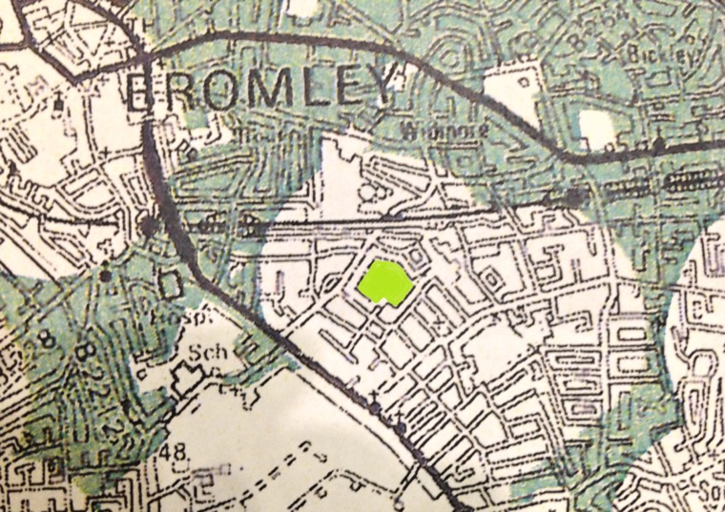

Appendix A8 - Entry for Havelock Rec in the Draft Local Plan:

Site 53
Havelock Recreation Ground
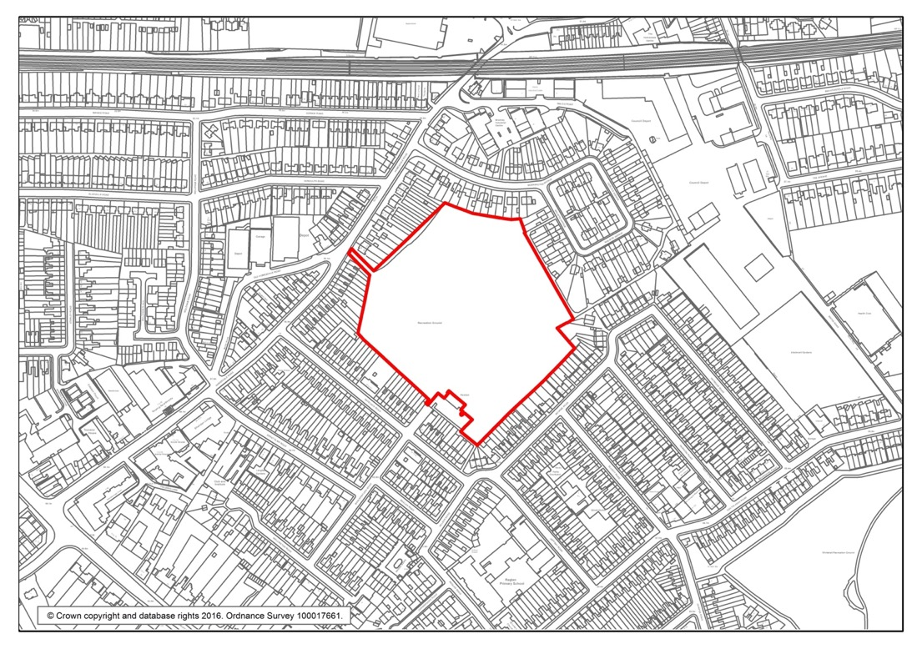
Havelock Recreation Ground Havelock Recreation Ground- Statement of Significance
Havelock Recreation Ground, locally known as “The Brickfield”, is accessed via a public footpath off Homesdale Road (the A222) where it provides a quiet and secluded green space shielded by the surrounding residential properties.
The site became an Asset of Community Value in 2015, having been nominated by the Friends of Havelock Recreation Ground. Existing brickworks were extended to this site by Coles Child, a merchant and Lord of the Manor, in Victorian times. The disused brickfield was converted into a recreation ground by Bromley Council in 1963. The grounds have been used by the 3rd Bromley Scouts Group since its opening for games and other scouting activities. It is also used by the local Raglan Primary School for outdoor activities and for general fitness and leisure activities by local residents. The Friends of Havelock Recreation Ground frequently organise local community events including picnics, hoedowns and Dog Olympics. Some of these events have been sponsored through donations of the Homesdale Road and Chatterton Road business communities.
The site’s biodiversity, which is in an area known to be deficient in access to nature, has been enhanced and improved through activities organised by the Friends Group such as bulb and hedge planting. There are hedgerows of native species on the site, which provide a good habitat for birds; house sparrows, common black-headed gulls and starlings have been sighted. There are areas of long grass which are good for pollinators as well as mature specimen trees on the eastern corner. The site also hosts a population of stag beetles. The Friends Group have organised biodiversity-related fun or educational events such as bird box painting and bug hunting sessions for children and families.

Appendix A9 - London Borough of Bromley Biodiversity and Arboriculture:

Bromley Biodiversity Action Plan
The London Borough of Bromley boasts an impressive range of wildlife, having species and habitats in common with
both Kent and London. It contains London’s largest area of countryside, stretching down to the crest of the North
Downs, and a good proportion of London’s semi-natural habitats. In order to protect these habitats, many areas of
the borough are designated in the UDP/Local Plan as Sites of Importance for Nature Conservation (SINCs). Some sites
hold other designations as well; at the local level as Local Nature Reserves (LNRs), within London as Sites of
Metropolitan Importance (SMIs) or are of national importance as Sites of Special Scientific Interest (SSSIs). Wildlife is
not restricted to open countryside, but thrives in urban areas too and in a wide range of situations.
http://www.bromley.gov.uk/downloads/download/667/bromley_biodiversity_plan
In consultant with the BBAP group the contract specification has been altered most recently an agreement was
reached do not treat or cut hedgerow bases, leaving a border of at least 50cm to preserve and create habitat. This
agreement included working with Bromley Customer Service teams and volunteers groups to improve public
understanding and deal with concerns raised.
As well as observing the plan and reporting back to the BBAP group, other knowledge and guidance will be sorted
and shared with organisations such as the following.
• Open Air Laboratories https://www.opalexplorenature.org/
• Greenspace Information for Greater London http://www.gigl.org.uk/

Arboriculture
Bromley’s Tree Strategy has been prepared in response to National, Regional and Local policy frameworks that
necessitate the creation of borough-wide tree strategies and accentuate the importance of protecting, maintaining
and enhancing trees and woodlands. An overarching principle of existing policy is the principle that all Bromley’s
trees and woodlands, both in public and private ownership, should be considered as a single ‘urban forest’. To
ensure trees are planted, preserved and managed in accordance with good arboricultural practice, with regard to
their contribution to amenity and the urban landscape, for both current and future generations.
Bromley’s publically owned tree stock includes over 24,000 park trees. In addition LBB manages hundreds of
thousands of trees across 552 hectares of publicly owned woodland and conservation sites.
http://cds.bromley.gov.uk/documents/s50037210/
Enc.%201%20for%20Arboricultural%20Strategy%20and%20Staffing.pdf

Property repairs
Valuation and Estates is a section of Property Division which provides professional property advice to the Council.
The council owns a wide variety of land and premises which are used for its own and for investment purposes. They
maintain a property register showing their ownership. This has recently been commissioned to companies within the
private sector.
The Council's property investment portfolio is now managed by its externalised Valuation and Estates function
through Cushman and Wakefield. This work includes management of a wide range of commercial and community
properties lettings, rent reviews, lease renewals, dealing with repairs, (through Amey) estate management of several
farms in the Green Belt, as well as several grazing licences and other licences for the use of Council-owned land

Appendix A10 - iDverde statement on park users and staff:
Park users
The safety of both park users and our staff is of the utmost importance. By having local teams of people who work the same areas - the public get to know and talk to the grounds staff. Being part of the community in which we operate, not only helps us understand the needs of users, and what concerns them , but the public seeing a friendly face in uniform makes the them feel confident in using the park because they have someone to share and report issues to.
For information on the Health and safety policies, please refer to Section Three of the Grounds Maintenance Specification and the Risk Assessment, Method Statement and COSHH folders available in each yard / office.

Park and green spaces are for everyone to use, whether to work, rest or play. Being aware of other people in the park and respecting each others wants and needs, is not only something we communicate to employees, it something we expect from all park users. Each green space is governed by bylaws that define what is permitted in a park or green space. The borough’s park bylaws can be found http://www.bromley.gov.uk/downloads/file/760/by-laws_for_pleasure_grounds
As in most communities, the majority of dog owners are responsible and that is reflected in the level of incidents that have to be dealt with. Responsible dog ownership and the consequences of the lack of training, (ie being let into a play area or fouling) is recognised as an ongoing issue and addressed by the authority with campaigns such as Be a responsible dog owner and where the situation warrants, intervention by the Borough security team, Ward Security who have the ability to issue Fixed Penalty Notices. http://www.bromley.gov.uk/info/200089/street_care_and_cleaning/242/responsible_dog_ownership
As the management agent for the Council, working with other contractors and agencies idverde do their best to ensure everyone is able to use the green space as they desire.
Every day the park as a whole is inspected, but particular care is taken in the play area with equipment being visually checked. Any issues, depending on the nature and severity are dealt with by the person(s) present, reported by phone to a reactive infrastructure team or to the playground equipment contractor via the parks management system.
Each year a survey of the all the infrastructure is done, including: bins, benches, play equipment, fencing, and paths.
Our staff
idverde prides itself on providing a safe and healthy environment for all of its employees, visitors, contractors and members of the public. All staff are adequately trained and competent for their role.
Staff receive health and safety training as part of their induction together with task specific training. A training matrix is in place and is used to track skills levels and provide gap analysis within the contract.
All staff are provided with Personal Protective Equipment and instruction on its proper use. Health and safety awareness is further supported through regular Toolbox Talks, Risk Assessments, Method Statements and Control of Substances Hazardous to Health sheets.
Matters relating to health and safety are discussed at regular meetings at which minutes are taken and any concerns are raised by employees at these meetings …
Incidents and near misses are, in the first instance recorded in the Near Miss Record Pad which are available from depots / yards and offices. The information is used to make adjustments to procedures, and inform where repairs are required – part of the drive to constantly improve, making both work environments and park as safe as they can be.
Whenever The Friends of Bromley town Parks work in any of the town centre parks, they will follow health and safety guidelines and are covered with insurance through the Friends forum.
http://www.bromleyfriendsforum.org/

Appendix A11 – Idverde’s Sustainability policy

It is now expected that everything should be done to minimise the environmental impact of business, this is particularly pertinent to the grounds maintenance industry. idverde should be setting an example to others.
When the contract was let, the Council challenged the company to achieve ambitious year on year reductions to the amount of green waste going to land fill. Today 100 per cent of the green waste idverde generate is reused or recycled.
Green waste is collected from site and then taken for processing at the Beaverwood yard, (in Chislehurst). After processing the screened and filtered material it is taken to be further processed and then sold as a soil enhancer.
Peat is not knowingly added to the site. Conditioning is achieved through labour and reusing of green waste material. Small amounts of peat may be added inadvertently to the site when new planting is installed in shrub beds. Bedding plants are peat free.
The tree stock in parks and green spaces is monitored on a rolling three year program and routinely inspected for signs of weakness and/or disease. The local authority’s in house arboricultural team, uses a dying, dead and/or dangerous criteria under which trees work is considered and prioritised. Any works required will be done by their contractor, Gristwood & Toms.
Like many parks, opportunities to install new beds are few and far between. That being said, we are fortunate in the Borough to have an active business community and Friends groups who wish to ‘put something back’.
Bi- monthly meetings with the Bromley Town Centre Friends group enable idverde to assess the needs of the community and update or improve facilities where necessary.
idverde is responsible for ensuring no material damage is done by the application of pesticides. All herbicides, fungicides, insecticides or other pesticides used shall have been approved by the Pesticides Safety Directorate (PSD) and used in ways which conform to all statutory regulations. Pesticides are used for and applied as prescribed by the UK Pesticides Guide www.cabi.org Records are kept where pesticides / herbicides are applied. (available on request)

A12.Idverde’s Foreword & Introduction

We are delighted to be expanding the Green Flag family and having approval to enter three new sites on behalf of the London Borough of Bromley.
The partnerships between idverde, the authority’s contractor, the Council and the local community have had a demonstrable impact on the quality of the Borough’s parks, countryside and green spaces. Green Flag accreditation will further affirm that belief and give significant public recognition to the improvements made.
By obtaining Green Flag status we are able to demonstrate to the wider community the effort put in and the pride taken by all of the park’s stakeholders in making a difference to the environment, health and wellbeing of local people; and the prosperity of our park.

Introduction
The London Borough of Bromley is the largest geographic borough in London with almost 160 publicly accessible open spaces, with nearly 50% of those having custodians in the form for Friends groups and other interested organisations. idverde are committed to produce strategic management and yearly action plan(s) for each of the boroughs green spaces.
The aim of this management plan is to demonstrate how idverde, in conjunction with stakeholders will implement the management and action plan(s).
Aims and objectives
- idverde aim to create vibrant landscape and empowered communities
- idverde encourage strong, inclusive and connected communities
- idverde will deliver attractive, biodiverse and sustainable parks, green spaces and countryside
- idverde strive to provide quality services and value for money
Good quality, well-designed parks and greenspaces make a critical contribution to our neighbourhoods, towns and cities and to people’s quality of life and play an important role in creating a sense of place. It is vital such environments are fit-for-purpose: clean, safe, attractive and well-maintained.
The benefits of safe and accessible parks and open spaces can be summarised as follows:
Social  - providing safe outdoor areas that are available to all members of the local population.  - creating opportunities for community events, voluntary activities and charitable fund raising.  - enabling easily accessible recreation as an alternative to other more chargeable leisure pursuits.  - championing opportunities to improve health and take part in a range of outdoor sports and activities.  - securing an educational resource or outdoor classroom. | Environmental  - building habitats for wildlife as an aid to local biodiversity.  - seeking to stabilise urban temperatures and humidity.  - absorbing pollutants in the air and ground water.  - granting opportunities for the recycling of organic materials.  - considering opportunities to reduce transport use through the provision of local facilities.  - designing walking and cycling routes through urban areas | Economic  - growing a positive environment for businesses to locate and develop.  - adding value to surrounding property, both commercial and residential, thus increasing local tax revenues for public services.  - contributing to attracting visitors, including using the park as a venue for events.  - encouraging tourism into the area.  - helping to create an attractive local image.  - seeking to reduce social exclusion and its associated costs to society.

A number of stakeholders were involved in the development of the plan, including the following:

- Bromley Biodiversity Partnership;
- Parks Greenspace and Countryside Panel (Stakeholder Engagement Forum);
- Bromley Friends Forum;
- The Friends of Bromley Parks.

Working document.
When creating management plans idverde takes the view that the document needs to be accessible and relevant to the day to day management of the site as well as fulfilling a strategic role. To that end larger documents and files have been referred to within, rather than included in full. Copies of documents and files are readily available to staff and can be made available to third parties on request.

