8.4 Supporting data for these proposals:

The things that have been identified as wanted by the park users surveyed:
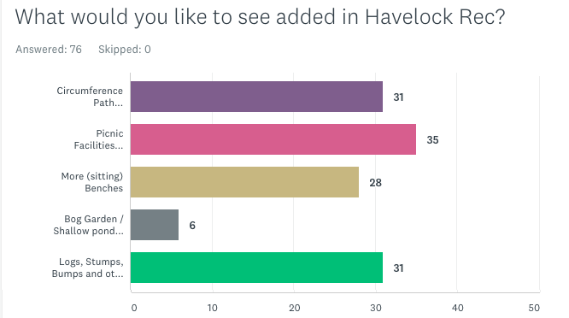
In the free-text entry:
“It is the combination of the character of the green space and the needs and expectations of the wider community, including people who do not use the green space, that informs every stage of the development of the management plan”
- BBQ area
- Childrens Playground – this can be ruled out on costs grounds (and there is one in Whitehall Rec and another in Norman Park) and because a number of respondents specifically said they didn’t want it in the ‘what do you particularly not want to see in the park’ free entry text field.
- Outdoor gym / pull-up bars
Other ideas:
- Human sundial bricks (to make a feature in the park to focus outings and commemorate the brick making heritage)
- Audio trail – this is of necessity waiting for the oral history work to be recorded.
- Adding logs and bumps natural features which could enhance the unstructured play opportunities
- Development of the Homesdale Road entrance to replace the broken railing with railway sleeper boxes
- Planting trees behind the ‘pikey posts’ to improve their appearance, and/or railway sleeper raised beds
- Adding native species climbing flowers to the friend’s storage container.

We need more bins, and ones that are fox proof.

Practical Management Plan for the Year
Paying attention to -
- Growing seasons
- Wildlife disruption

LBB - London Borough Of Bromley
IDV - Idverde
FOHR - Friends of Havelock Recreation Ground

9. Site Management

Please see the idverde statement in appendix A6.
Other parks in the town ward have bi-monthly meetings with their park officer. This sounds like it would be a useful thing to have for our park too; perhaps every six months?

10. Sustainability
Please see the idverde statement on sustainability, in appendix A11

11. Document review and site / work review

The friends would welcome a regular meeting to inspect park, troubleshoot issues, and review the plan. Other ward parks meet with their park officer on a monthly basis, but as the Friends consists principally of volunteers who hold full time jobs (or are working around the needs of small children and/or school runs), it might be more practical to meet 3-monthly (if that is possible).
This document is expected to last for 10 years, but it is felt that it should be reviewed, updated, and amended every two years. This would then incorporate any changing situations.

