3. Demographics
The park is in the SE corner of the Bromley Town ward. The surrounding roads are inhabited by a blue/white collar, white and mixed race people.
These are the roads that many of the park users live in:
These are from the survey results: (1) the 70 results in 2018; (2) the 2015 one for the village green application of 90 results. Homesdale road is characterised by a lot of flats; some older ones above the shops, and many in the new blocks (since the year 2000)) at the A21 end.
Census data was obtained from Streetcheck website, who had already categorised it. It was collated over several of the census areas close to the park (see Appendix A1):
Housing Type: | Flats make up the largest type at 35% (which will increase at the next census), followed by semi at 26% and terrace at 22%
Housing Tenure | 40% are mortgaged, and 32% rented (LBB never had much council housing so that includes 6% social rented)
Social Grade: | Streetcheck's analysis tool says that 40% have "" and 28% management/professional work, with 12% on the 'lowest grade' of unemployed/ unskilled workers.
Education / Qualifications | Slightly higher proportion-than-the-national-average are well educated (36% with degrees or above compared national average 34%) whist 22% have no GCSEs or 'other' (eg School Certificate)
Ethnic Origins | The area is a bit more diverse (82% white) than average for England (86%) with the largest non-white groups being Mixed (4%) and Black African (4%)
Country of Birth | Nearly 80% of residents were born in England, with al  most 5% coming from the EU and 9% from 'other'.
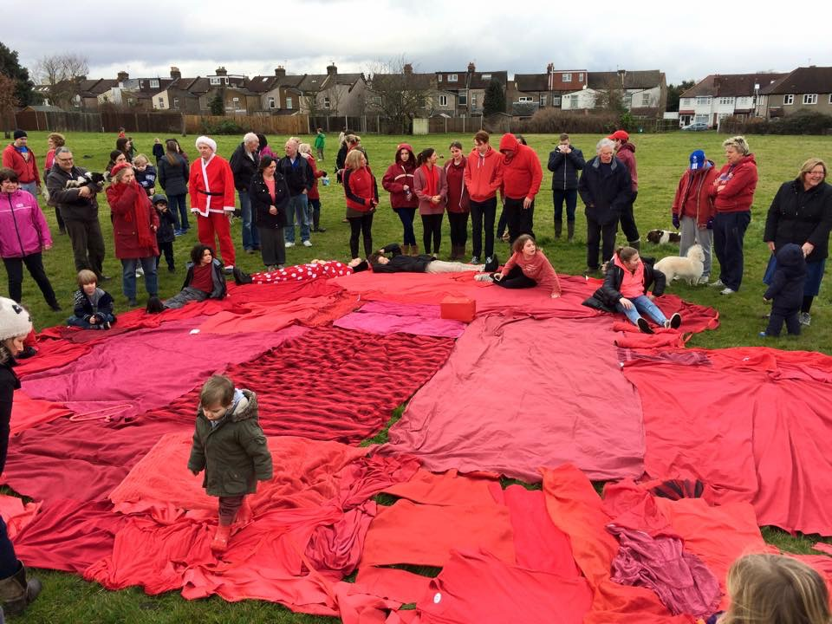
The Park is the Heart of our Community, campaign event on 14th Feb 2015.

4. History and Heritage

Havelock Rec began life as the brick pit, kiln, and brick works, for the Lord of the Manor, Mr Cole-Childs (he purchased the Lord of Manor title from the Diocese of Rochester in 1845) who “built an extensive brickworks on the southern boundary of his estate”. The deepest part of the workings was a pit, possibly 60’ deep at the Eastern side. There are more details and photographs on the website at (http://friendsofhavelockrec.org/local-history-brickfield-and-area/#hist) and also contributions from local residents who remember it during, or not long after, WW2 (http://friendsofhavelockrec.org/oral-history-of-the-local-area/).

For management purposes, it is useful to know that the original London clay is present for in a 10m deep strip on the southern boundary of the park. This original London Clay is the better substrate for planting on. The remainder of the park is turfed-over rubble, rubbish, and the left-overs from the gas works (who owned it). There are some photographs of it as a working pit from 1921, taken by a British Geological Survey geologist, also at http://friendsofhavelockrec.org/photos-working-brick-pit/, British Gas then passed ownership of it to the council, and their agent Mr McIntosh, grassed it over, so it was opened to the public in 1952.
Some issues to be aware of:
1960s – The council had to compensate a Millwall FC player from injury from glass emerging from the landfill in the park.
1990s – the Liberal Democrat council proposed to create a Havelock Wood (!) over the entire park by not mowing any longer. Their administration ended with a by-election in this ward, where the residents all demanded that their park should be mowed again.
2004 nursery doubled in size (for the 2nd time), and illegally fenced in the car park (the fencing in the planning application did not include the car park).
2008 nursery applied to expand their lease/area to 1/3 of the park, but action by local residents meant that this was refused.
2015. As previously mentioned, the park was put forward to the Education Funding Agency as the site to build a new school (approx. 900 pupils) by the council’s Development and Regeneration Officer.
Though the park is modest, it is much valued by the local residents, who formed the Friends of Havelock Rec when it was threatened in 2015 (see right). Since then, the park has been better cared for, and is cleaner.

5. Social Links

The park is used for events held by the Friends, most years this includes a Big Lunch and a Bug and Bird activity day. As a proportion of the committee also manage Whitehall Rec, we are limited to the summer weekends (when school holidays are also considered) that events can be held, as they can’t coincide with major Whitehall events like Apple Day and the beer festival. There is a great deal of benefit to the Whitehall Rec connection as much expertise and equipment is shared.
The park is also used by Gateway to All Sports Project (GASP) to hold classes and after school activities.
The friends are hoping to develop links with Raglan Road school. We feel that the park has much to offer as a place to study and play. In particular, they would like to see the annual sports day held in the field instead of a concrete playground.

6. Summary of improvements since 2015

When the park’s friends group was formed in 2015, the park was not well maintained and gave the incorrect appearance of being un-loved. This section is about the changes to the park since then.

6.1 Improvements on the Ground

In February 2015, Dr Judy Johns did a biodiversity report on the park, and made some recommendations, which the friends have attended to, though some proposals had to be amended to reflect other things that have come to light since. The full report is in #A3: Biodiversity Report from 2015:
Temporary notice boards were placed at the entrances, having gained special permission, in spring 2015.
In 2017, Idverde started to litter pick it a few times a week in the early morning. This has improved the park and we find that a tidy park discourages dog owners from not picking up.
Trees (broadleaf) were planted to replace gaps in the perimeter planting, but those over the rubble infill of the brick pit, have suffered in dry spell the park suffers from every June, so many are struggling and a few have died. The ones behind the houses on the Havelock side of the Park, have been watered by residents with gates onto the park, and have mostly thrived.
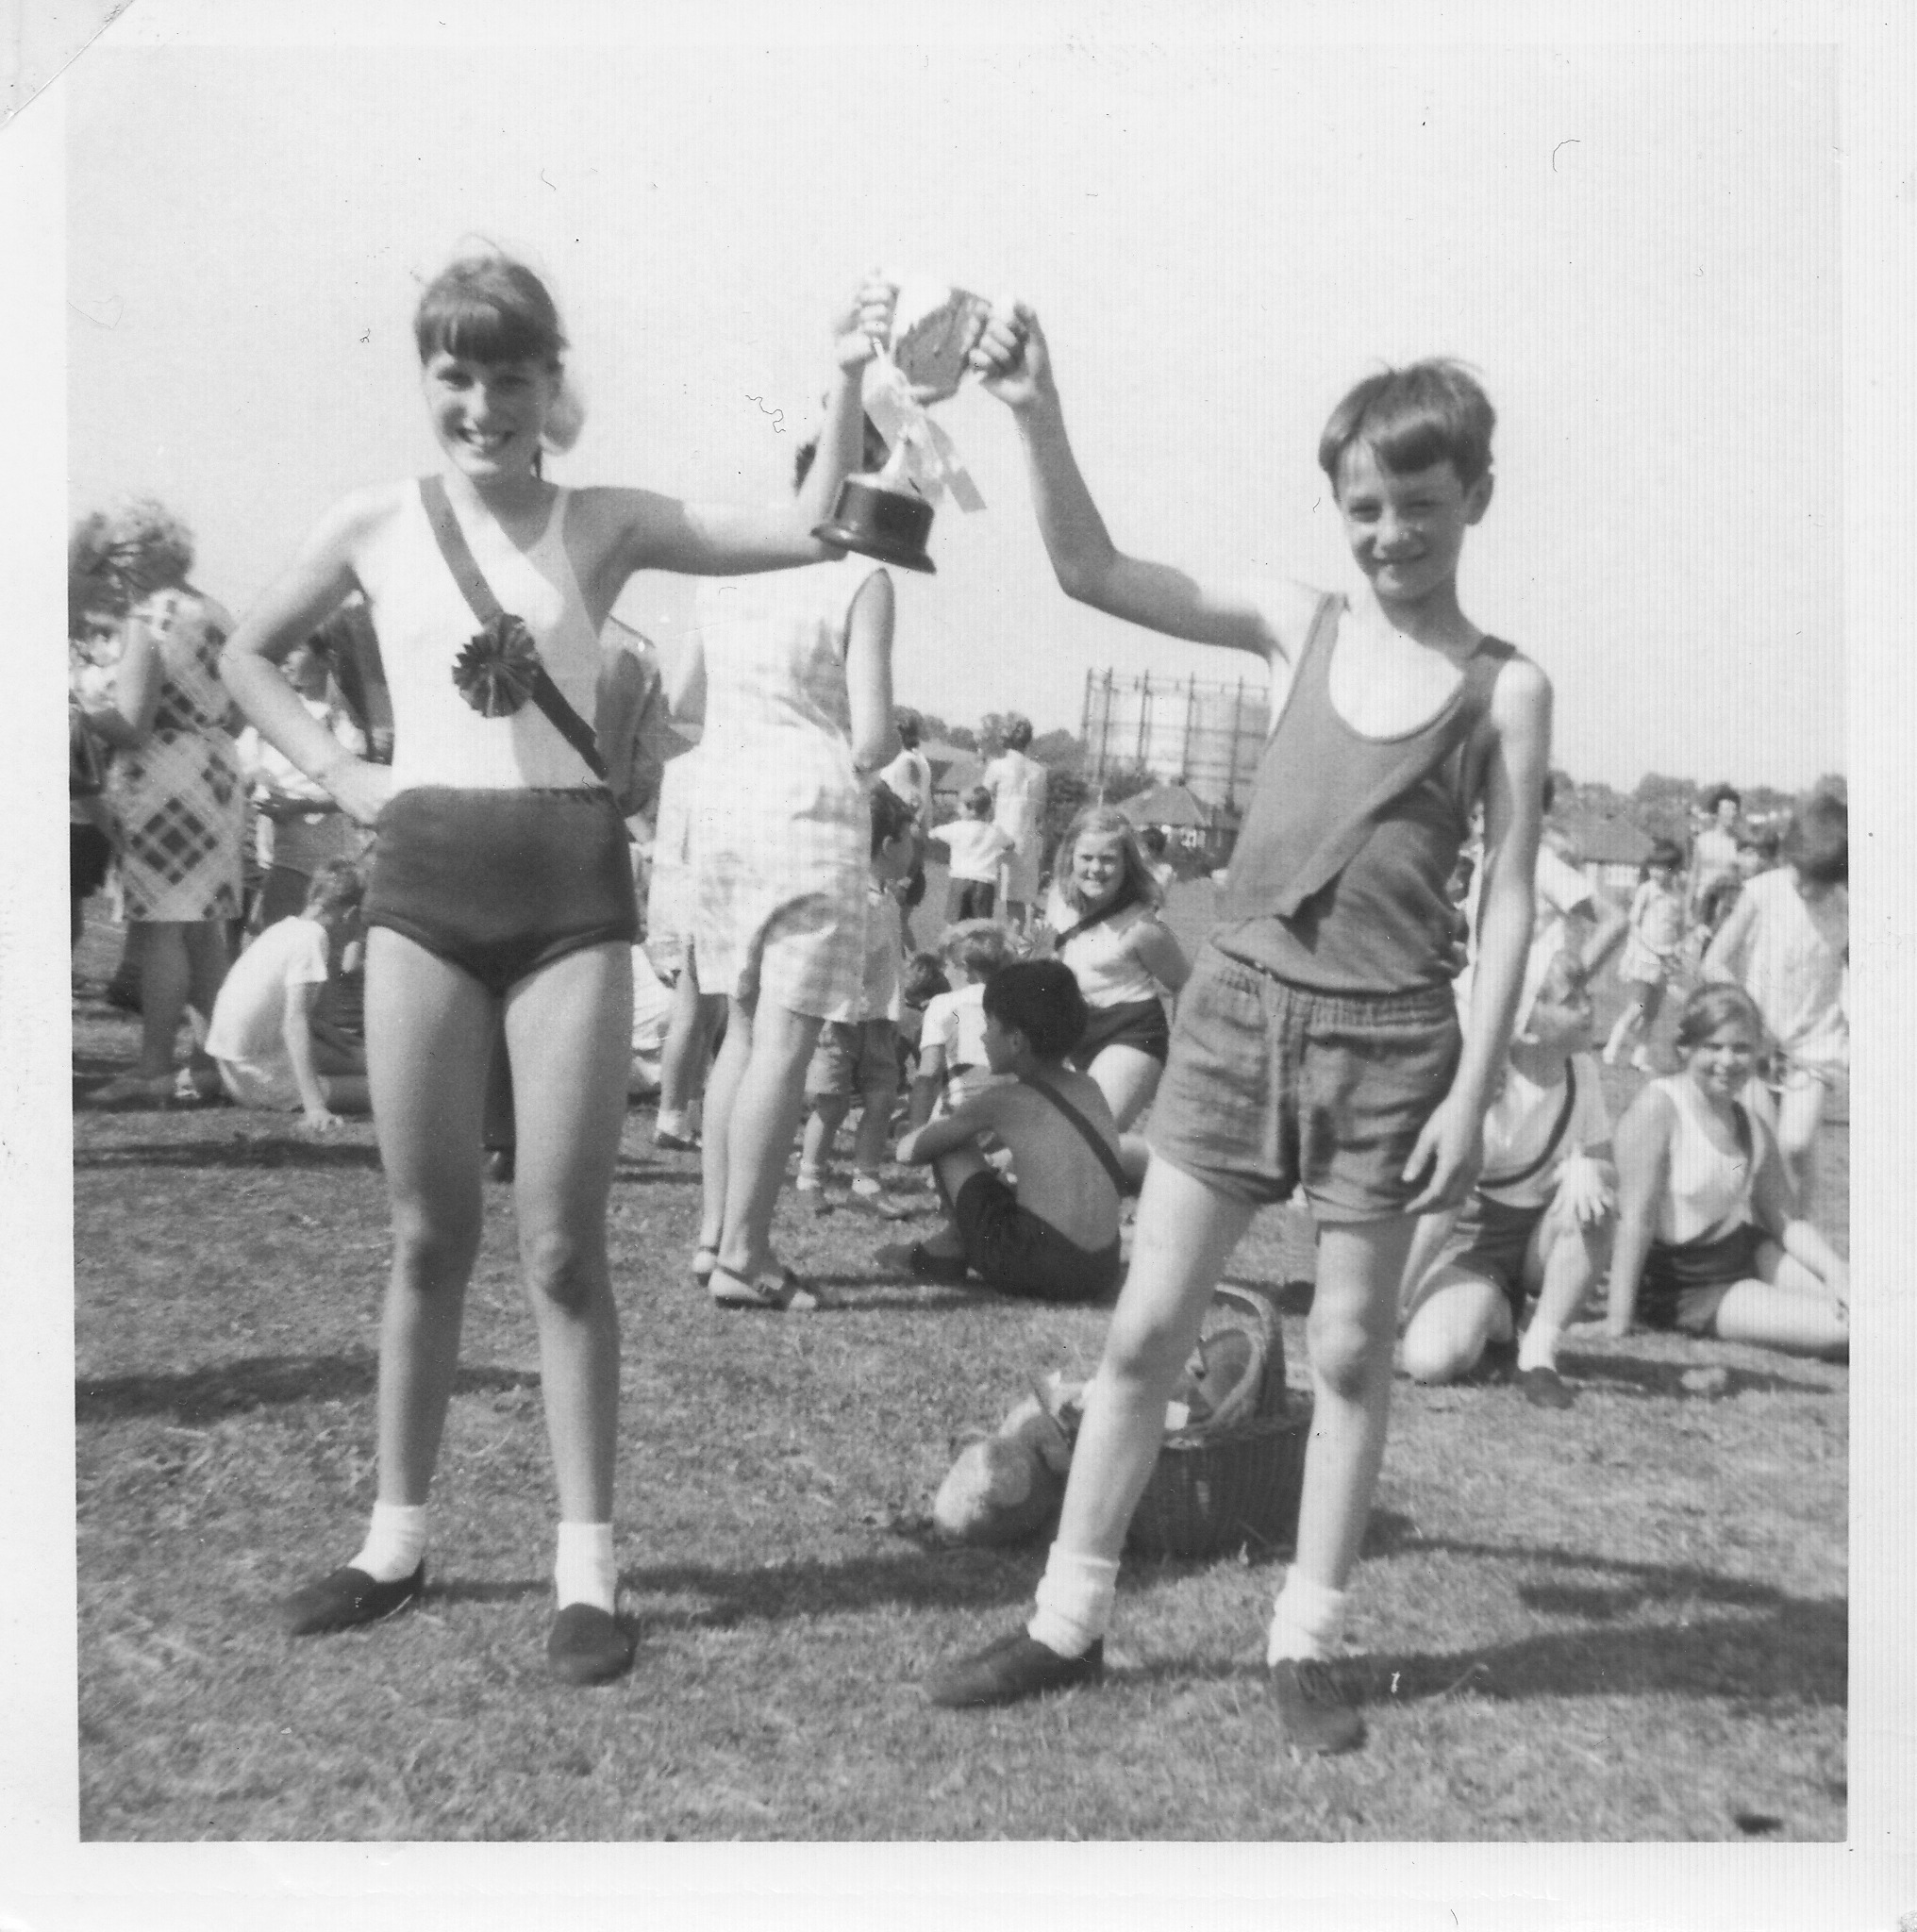
Raglan Road sports day on Havelock Rec in 1969.
Some spare Scots Pine trees were planted the SE corner, forming a pleasant grove at the end of the hedge, in the winter of 2017. At the time of writing, after re-staking in 2018, they are alive.
The friends have been planting a hedge along the chain link fence, in winters of 2015/6/7 – these whips tend to be thinned out in the June dry-out so this area is getting a natural dispersed layout with a variety of species, provided (and thanks to) Evo Energy.
In spring 2018 it was finally agreed to leave an area of longer grass to provide a meadow area and improve bio-diversity. This meadow area changed (from the one recommended in the Biodiversity Report, Appendix A3). It is narrower against the northern chain-link-fence boundary, due to wanting benches to be attractive/accessible) and added around the trees on the southern boundary because that was the only part with the original London Clay underneath.
Dogwood (coloured) was planted at Homesdale road entrance, though there are gaps that need replacing.
In 2018 the friends restored the Canadian High commission plaque in memory of Patricia Ann Drennan that was removed when the nursery expanded.

6.2 Improvements with the Park’s status
When it was announced that a school would be built on the park, the friends applied for Town Green legal status for the park, but the council refused to register it.

However, the park was registered as a Local Community Asset (number 18 for Bromley) under the Local Government Act.

In 2016 it became possible to register parks (among other sites) as Green Spaces and the friends successfully applied for this.

7. Policy and Strategic Context
Friends of Havelock Recreation Ground – our Purpose and Objectives are:
1. Maintain the open vistas and big skies of the park
2. The park should be about freedom not restriction. Let the wide-open spaces be used by the community in ways that they desire.
3. Try and increase the natural diversity of the park, but not detracting from points 1 & 2
4. Make the park a more rewarding experience for our visitors
5. Work under the supervision of the council* to maintain the park in good order and to try and achieve the objectives highlighted in the previous points

*the professional officers of the London Borough of Bromley (LBB)

The mission statement of the Friends is quite simple, because most of our users surveyed wanted it to stay more-or-less the same (See survey result in Appendix A1)
See Appendix A7 (with thanks to Idverde for drawing this up in their template) for the national planning policy framework. Extracts from the draft local plan and 2016 Building A Better Bromley have been included in this appendix.
The council, their contractor Idverde and Friends groups / Friends Forum should work together to further enhance the vision for the park linked to future aims.

