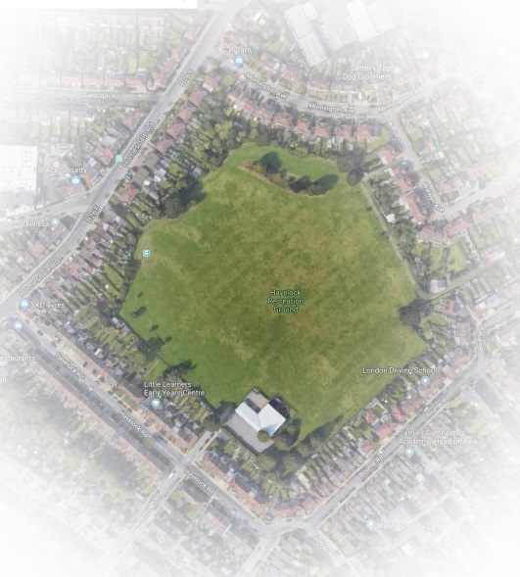

HAVELOCK RECREATION GROUND

Management Plan 2018 - 2028

Acknowledgements:
Friends of Havelock Rec (FOHR)
Friends of Bromley town Parks
idverde

Title: Management Plan for Havelock Recreation Ground

Contents

The Park.
About This Plan
Demographics
History and Heritage
Social Links
Summary of improvements since 2015
Policy and Strategic Context
Plans to Improve the Park
Site Management
Sustainability
11. Document review and site / work review
Appendices:
Including survey results and idverde policy documents referred to in the main body.

Authorship: Caroll Long, Idverde Community Manger. Emma Prescott, Chair of Friends of Havelock. Kerry Hood, Friends of Havelock.
Date created: November 2018
Date last updated: (in draft form)

1. The Park.

Havelock Recreation Ground is located in Bromley Town Ward of the London Borough of Bromley Local Authority.
Havelock Recreation Ground is a modest, square, largely level site of approx. 9 hectares surrounded by terraced housing and blocks of flats. There is a ‘B’ road on the west side (with entrance) whilst the remaining sides are minor roads.
The park has unrestricted access.
The locals also call it the ‘Brickie’ or ‘Brickfield’ because it is the site of a former brickworks and pits for the Lord of the Manor. Subsequently British Gas (or it’s predecessor) purchased it to dump the waste from the former town gas works and rubble from the Blitz. There is a nursery in the SE corner (about 1/8 of the site) that is the successor to Milwall FC’s sports pavilion. There is a dip in the NW corner, on the site of the smaller first quarry that appears in older maps. It is bounded by the gardens of residential housing, (meaning it is not visible from the surrounding roads) except along the north side, where there is a chain link road and a green lane to Waldo Road dump.

Over the years various trees have been planted around the perimeter, some of which have survived. Since the friends group was created in the spring 2015, they have also planted shrubs in a couple of places.
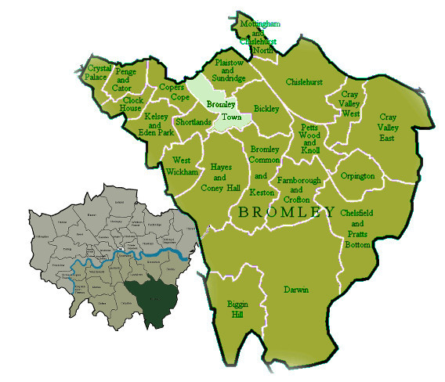
The Town Ward is in the north of Bromley borough, which is in the SE of Greater London

In 2015 the park was suggested to the Education Funding Agency as the site for La Fontaine school, by the council officer for Development and Regeneration. This was the 3rd attempt to dispose of all or part of the site, which has made residents quite defensive about it and distrustful of the council; they have a tendency for accosting high-vis workmen and asking them what they are doing… which is unfortunate for the environment agency workers who don’t want to say they’re monitoring the landfill.

People use the park for walking their dogs (as it has fences around it and feels secure), playing games, enjoying the open space and for events by the friends (see Appendix A2Full survey results for a full list). The park is also the best place, for a long way, to see a sunset (because of the open aspect).
Address: Havelock Road, Bromley, BR2 9NY
OS Land ranger Map Sheet 177 Grid Ref: TQ419681
Latitude: 51.3942 Longitude: 0.038221
Train links are Bickley Station and Bromley South Station.
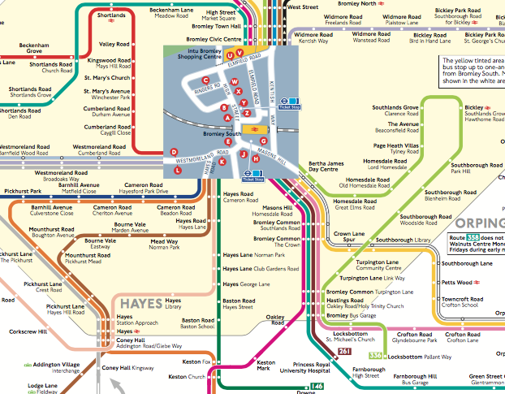
Local Bus Route map
It is the only non-ornamental park within the Town Ward, and is in the bottom corner, close to the A21.
Bus links nearby include 61, 208, 261, 269, 358, and 336

Friends Events include:
- Big Lunch
- Birdbox and Butterfly Day
- Fun Day
- Other ad-hoc events, from Easter Sports Day to Bulb Planting.

2. About This Plan

This is the first management plan for Havelock Recreation Ground.
It is expected that it would have minor revisions every 2 years.
The layout attempts to be concise, with appendices to explore information, such as survey results, policies, and census data, in full.

2.1 Aim:
The intention is to prepare a plan to develop a strategic and practical framework to improve the park for all parties with an interest.
The purpose of this plan is to:
- Identify, discuss and resolve issues relating to park infrastructure, park users and available resources
- Describe the method of managing and maintaining Havelock Recreation Ground
- Identify and address who is responsible for specific aspects of management and maintenance
- Deliver a benchmark against which delivery and performance can be measured.
- Share knowledge and experiences

3.2 Authorship:
The plan has been drawn up by Kerry Hood from the Friends of Havelock Rec (FOHR), with the collaboration of our committee and the chair Emma Prescott. A template was provided by Caroll Long (as cited on this Friends Forum list) the park’s officer at the council contractors, Idverde.

3.2 Consultation:
Park users were surveyed so that they had a chance to input into the process. Initially this was by interviewing them on the field, then it the consultation was published in the friend’s email newsletter and a link provided on their website. Finally, the survey was taken around to the local shops and businesses so that they could have an input. There was no response from this exercise.

