Appendix A6. iDverde’s management procedures & plan:

(annotated by Kerry Hood as some of these statements don’t apply to our park)
Grounds Maintenance is more than just cutting the grass and emptying the bins. Ward based teams ensure operatives gain a deep understanding of their area and how its community functions. It creates a sense of pride, ownership and the ability to make swift decisions in changing conditions.
Litter and other small amount of waste or harmful material, such as broken glass and other detritus is observed and dealt with each morning as part of the site inspection and other visits are made during the day / week as required to ensure compliance with the contract specification. Litter is picked several times a week, when the bins are emptied (there is not detailed inspection - kerry)
Vandalism, fly tipping and other damage to the park or property within is dealt firmly with legislation be applied as deemed appropriate and to the full extent of the law whether that be as criminal damage or via Bromley’s internal enforcement team.
Policies and procedures were conceived at the time of outsourcing of the service and are reviewed and update jointly with the Council and other contractors to maintain levels of service and accountability. Please refer to the Grounds Maintenance Specification document, available on request.
Joint monitoring
Joint Monitoring is where a Neighbourhood Officer from the London Borough of Bromley goes around the site with an idverde supervisor to agree quality of work done taken from a random list.
Fly-tipping procedure
Any rubbish dumped in a park or green space that is less than 2 cubic meters and weighs less than two tonne in total we will attempt to remove as soon as is practical. Anything larger or heavier is referred to Bromley’s waste contractor. Burnt out motorbikes and other vehicles are either removed and stored by us by a third party or we assist in removal to the road side for collection by the local authority’s contactor.
Graffiti procedure
Graffiti on non-porous surfaces, less than 210mm by 297 mm in size is dealt with as soon as is practical. Offensive graffiti is dealt with as quickly as idverde are made aware of it. Large amounts of graffiti, or graffiti that is on hard to clean surfaces, is referred to a specialist contractor, Community Clean via the appropriate neighbour team at Bromley.
Fix My Street
This is an online reporting tool for the website or smart phone. It is primarily for reporting items which are broken, dirty, damaged or dumped, and need fixing, cleaning or clearing. These include graffiti, dog fouling, potholes or street lights that don't work. It is one of many tools idverde use to ensure we are responsive to local people’s needs and desires. Small amounts of damage, for example a broken fence panel is dealt with by our infrastructure team. More substantial work, such as damage caused by an attempted break in to a pavilion, will be referred via idverde’s enquires desk to Bromley and then to an appropriate specialist contractor. https://www.fixmystreet.com/reports/Bromley
With assistance from the Council’s in house arboricultural team, idverde actively manage the trees within that space removing dead limbs, basal and epicormics growth to pruning and shaping younger trees.
The contract document prescribes what must be done to maintain standards, but local teams understand the importance of parks to the community and attend proactively to issues to avoid escalation.

Appendix A7 - Policy and Strategic Context

A7.1 - Extracts from National Planning Policy Frame work

Promote Healthy Communities
- Access to high quality open spaces and opportunities for sport and recreation can make an important contribution to the health and well-being of communities. Planning policies should be based on robust and up-to-date assessments of the needs for open space, sports and recreation facilities and opportunities for new provision. The assessments should identify specific needs and quantitative or qualitative deficits or surpluses of open space, sports and recreational facilities in the local area. Information gained from the assessments should be used to determine what open space, sports and recreational provision is required.
- Existing open space, sports and recreational buildings and land, including playing fields, should not be built on unless:
  - an assessment has been undertaken which has clearly shown the open space, buildings or land to be surplus to requirements; or
  - the loss resulting from the proposed development would be replaced by equivalent or better provision in terms of quantity and quality in a suitable location; or
  - the development is for alternative sports and recreational provision, the needs for which clearly outweigh the loss.
- Planning policies should protect and enhance public rights of way and access. Local authorities should seek opportunities to provide better facilities for users, for example by adding links to existing rights of way networks including National Trails.
- Local communities through local and neighbourhood plans should be able to identify for special protection green areas of particular importance to them. By designating land as Local Green Space local communities will be able to rule out new development other than in very special circumstances. Identifying land as Local Green Space should therefore be consistent with the local planning of sustainable development and complement investment in sufficient homes, jobs and other essential services. Local Green Spaces should only be designated when a plan is prepared or reviewed, and be capable of enduring beyond the end of the plan period.
- The Local Green Space designation will not be appropriate for most green areas or open space. The designation should only be used:
  - where the green space is in reasonably close proximity to the community it serves;
  - where the green area is demonstrably special to a local community and holds a particular local significance, for example because of its beauty, historic significance, recreational value (including as a playing eld), tranquillity or richness of its wildlife; and
  - where the green area concerned is local in character and is not an extensive tract of land.
- Local policy for managing development within a Local Green Space should be consistent with policy for Green Belts.
Extracts from https://www.gov.uk/guidance/national-planning-policy-framework/8-promoting-healthy-communities taken on 9th December, 2018.

A7.2 Applicable extracts from 2016-18 Building a Better Bromley:
For a Quality Environment we will:
- Sustain a clean, green and tidy environment through value-for-money services provided to a consistently high standard.
- Encourage further improvements in recycling and seek to reduce waste to manage costs and protect the environment.
- Encourage Residents Associations and expanding network of ‘Friends’ to contribute to parks, trees and streets management and work with ‘Snow Friends’ during winter weather.
- Use our wide-ranging enforcement and regulatory powers in a fair manner to protect people and their neighbourhoods, thereby reducing costs associated with issues such as fly-tipping.
- Identify infrastructure investment opportunities to reduce future maintenance costs associated with maintaining a high quality street scene, including roads and street furniture.
For a Healthy Bromley we will:
- Work with health partners and focus on areas identified within the Health & Wellbeing strategy in improving health and delivering Public Health outcomes.
- Ensure that health and wellbeing priorities are integrated within all areas of the Building a Better Bromley framework.
- Work with our partners, stakeholders, and the public to take responsibility for themselves and their health and wellbeing by adopting healthier lifestyles. This will ensure less reliance on public services.

A7.3 Applicable extracts from the Draft Local Plan:

1.2.23 Bromley’s distinctive character arises from its protected open space: countryside, parks, gardens, playing fields and woodlands throughout the Borough. Tree lined roads/avenues and houses with gardens are distinctive features of many of the Borough’s residential areas. There are 131,000 households (2011 Census) made up of a variety of house types ranging from the older, more densely developed areas around Penge to the more spacious detached houses near to Farnborough and Keston.
Open Space and the Natural Environment 1.3.2
The value of natural spaces, whether private gardens, rivers, lakes or Green Belt, is recognised and afforded a high priority. Land, air and water environments are sustainably managed, ensuring that the wide range of different open spaces and habitats, with their distinctive animal and plant life, are well managed and accessible. As well as helping conserve and enhance biodiversity, Bromley’s natural environment supports the wellbeing of its communities, with open spaces and trees providing healthy environments and space for leisure and sport. Opportunities are taken to increase natural habitats, especially in areas with a deficiency, linking them together and improving their quality and accessibility.
1.3.3 Objectives Manage, protect and enhance natural environments. Encourage the protection and enhancement of biodiversity. Protect and enhance the Green Belt so that it continues to fulfil its functions. Improve the quality of open space and encourage provision in areas of deficiency and in any new development.
5.2.42 Some areas of [Local Park] deficiency are unlikely to be reduced in the foreseeable future. A priority for the Council will be addressing the lack of open space at local park level (2ha). Small local parks are particularly valuable to the less mobile, such as the elderly and carers with young children. Public open space can be provided appropriately as part of new housing, retail, leisure and employment developments.
5.2.2 The NPPF requires Local Authorities to set out a strategic approach in their Local Plans, planning positively for the creation, protection, enhancement and management of networks of biodiversity and green infrastructure. Policies should set out criteria against which proposals for any development on or affecting protected wildlife or geodiversity sites or landscape areas will be judged. Distinctions should be made between the hierarchy of international, national and locally designated sites, so that protection is commensurate with their status and gives appropriate weight to their importance and the contribution that they make to wider ecological networks.
Draft Policy 50 Metropolitan Open Land The Metropolitan Open Land (MOL) will be given the same level of protection as Green Belt. The exceptions to inappropriate development are consistent with Green Belt policy and permission will not be given for inappropriate development except in very special circumstances.
Draft Policy 56 Local Green Space Local Green Space is green or open space which has been demonstrated to have special qualities and holds particular significance to the local community which it serves. Development which causes harm to the “special qualities” of a Local Green Space as defined within its Statement of Significance but is otherwise policy compliant will be considered inappropriate and will not be accepted except in very special circumstances.
Draft Policy 79 Biodiversity and Access to Nature The Council will enhance biodiversity across the Borough, assist ecological restoration and address spatial deficiencies in access to nature by: Using the procedures in the Mayor’s Biodiversity Strategy to identify and secure the appropriate management of sites of metropolitan, borough and local importance for nature conservation in consultation with the London Wildlife Sites Board. Identifying areas deficient in accessible wildlife sites and seek opportunities to address them.
5.3.16 The Bromley Biodiversity Plan (2015) translates national and regional biodiversity strategies to the context of Bromley, particularly the borough’s biodiversity duty as set out in the Natural Environment and Rural Communities Act 2006 (NERC). It promotes a coordinated Strategy for conserving, protecting and enhancing biodiversity at the local level to maintain , enhance and restore SINCs and other biodiverse spaces. It provides best practice guidelines for protecting and enhancing biodiversity in the borough for all 156 Proposed Submission Draft Local Plan 5 Valued Environments stakeholders involved in maintaining and managing them including Friends Groups, planners and developers, landowners and contractors volunteer groups and the general public. The plan aims to sustain local species and habitats for future generations
In 2017 Havelock Recreation Ground was designated a Local Green Space.

Appendix A8 - Map of Local Park and the local Green Space Deficiency
This is from 2010. The areas (marked in dark green) are those of local ‘Green Space Deficiency’. The light green coloured area is Havelock Rec:
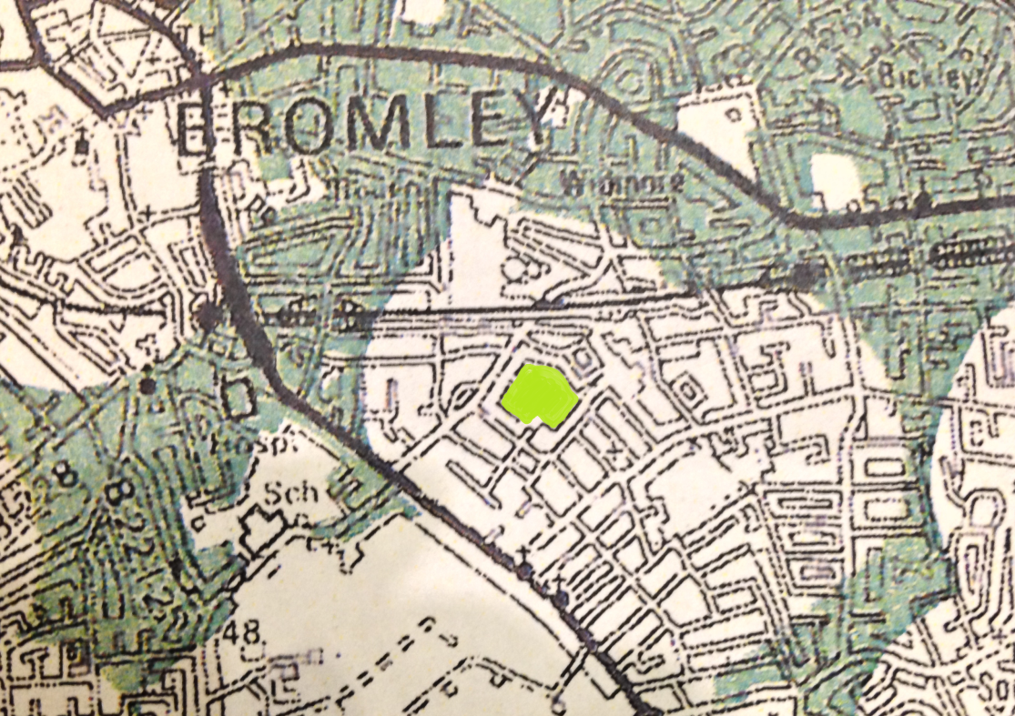

Appendix A8 - Entry for Havelock Rec in the Draft Local Plan:

Site 53
Havelock Recreation Ground
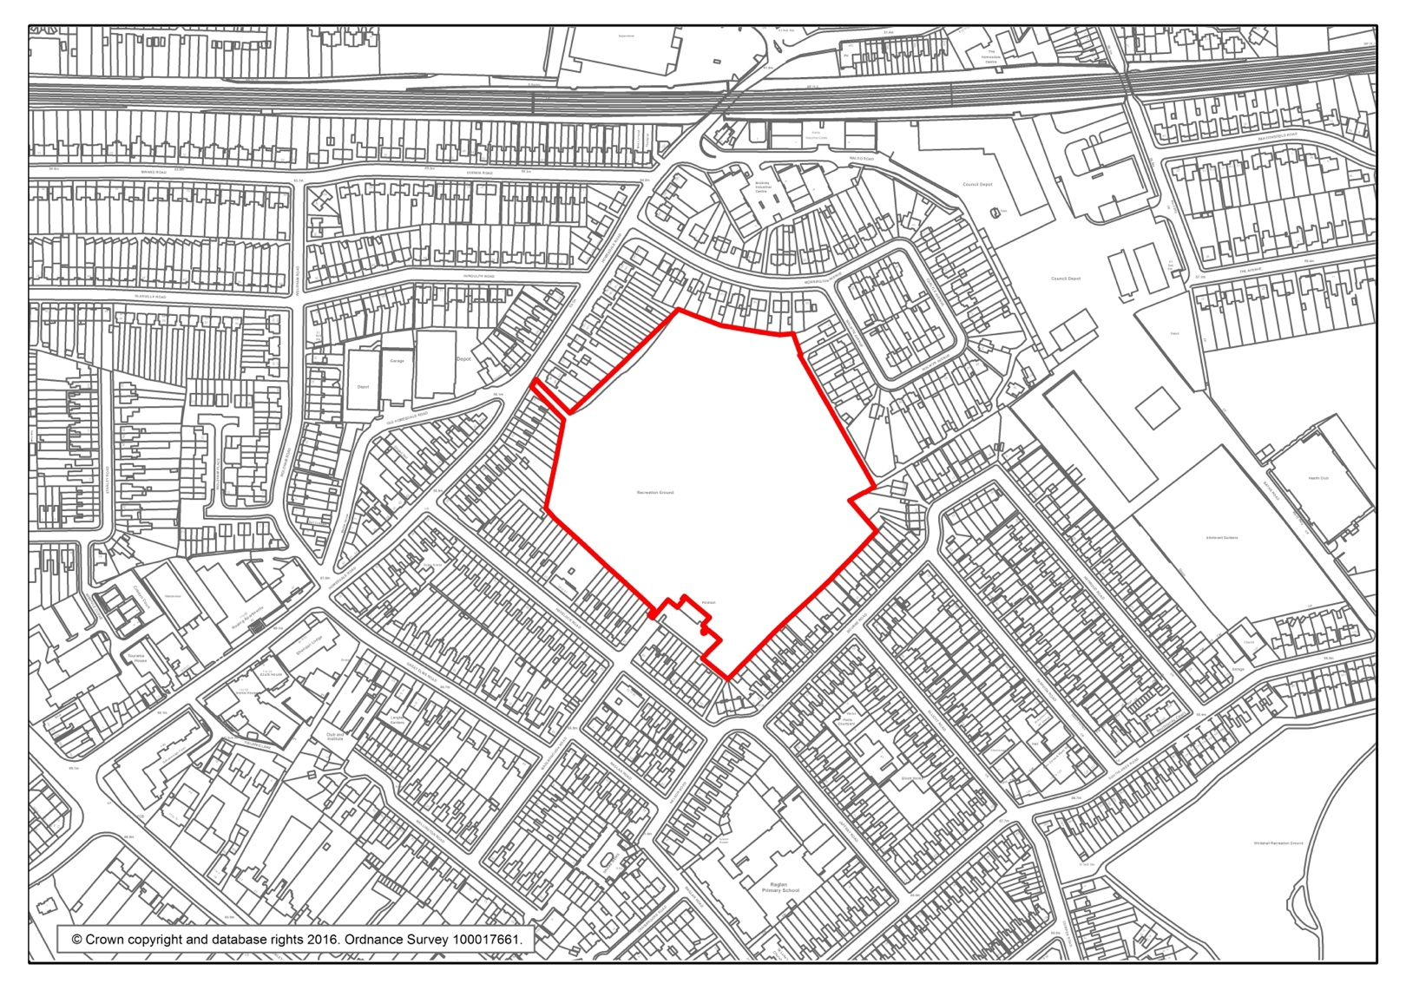
Havelock Recreation Ground Havelock Recreation Ground- Statement of Significance
Havelock Recreation Ground, locally known as “The Brickfield”, is accessed via a public footpath off Homesdale Road (the A222) where it provides a quiet and secluded green space shielded by the surrounding residential properties.
The site became an Asset of Community Value in 2015, having been nominated by the Friends of Havelock Recreation Ground. Existing brickworks were extended to this site by Coles Child, a merchant and Lord of the Manor, in Victorian times. The disused brickfield was converted into a recreation ground by Bromley Council in 1963. The grounds have been used by the 3rd Bromley Scouts Group since its opening for games and other scouting activities. It is also used by the local Raglan Primary School for outdoor activities and for general fitness and leisure activities by local residents. The Friends of Havelock Recreation Ground frequently organise local community events including picnics, hoedowns and Dog Olympics. Some of these events have been sponsored through donations of the Homesdale Road and Chatterton Road business communities.
The site’s biodiversity, which is in an area known to be deficient in access to nature, has been enhanced and improved through activities organised by the Friends Group such as bulb and hedge planting. There are hedgerows of native species on the site, which provide a good habitat for birds; house sparrows, common black-headed gulls and starlings have been sighted. There are areas of long grass which are good for pollinators as well as mature specimen trees on the eastern corner. The site also hosts a population of stag beetles. The Friends Group have organised biodiversity-related fun or educational events such as bird box painting and bug hunting sessions for children and families.

