Appendix A4: Analysis of 2011 census data from Streetcheck:

NOTE: this data is 8 years old and less accurate than it might be. On Homesdale Road, Iconia House, Azzura House, Garrard House and Rosing Apartments, were all offices, as was Berkeley House (formerly Archers court), opposite. The Dripping Tap (Woodham Apartments) was a shop and flats at Kentway Court on the Hayes Lane corner was a single house. These are now all flats, so have probably added 200 dwellings in the immediate area with no outdoor space (who might have more need of a local greenspace than properties with gardens).
The Areas:

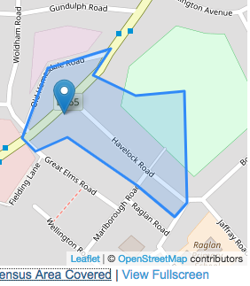 | 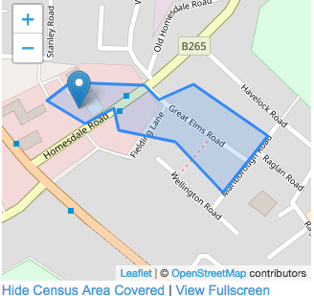
BR2 9NY, BR2 9NZ, BR2 9LD | BR2 9LY
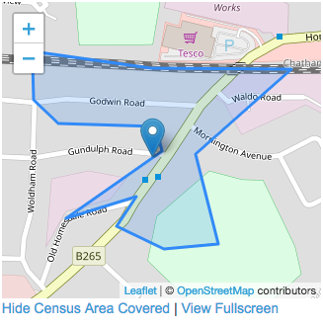 | 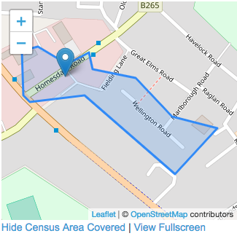
BR2 9LE | BR2 9NB

My Summaries:
These are my conclusions from the collated data:
Housing Type: | Flats make up the largest type at 35% (which will increase at the next census), followed by semi at 26% and terrace at 22%
Housing Tenure | 40% are mortgaged, and 32% rented (LBB never had much council housing so that includes 6% social rented)
Social Grade: | Streetcheck's analysis tool says that 40% have "" and 28% management/professional work, with 12% on the 'lowest grade' of unemployed/ unskilled workers.
Education / Qualifications | Slightly higher proportion than average are well educated (36% with degrees or above compared national average 34%) whist 22% have no GCSEs or 'other' (eg School Certificate)
Ethnic Origins | The area is a bit more diverse (82% white) than average for England (86%) with the largest non-white groups being Mixed (4%) and Black African (4%)
Country of Birth | Nearly 80% of residents were born in England with almost 5% coming from the EU and 9% from 'other'.

The Analysis on Streetcheck:
Summary of what the Streetcheck analysis is for each survey area (these were used as a start point):
question | BR2 9NY | BR2 9LY | BR2 9LE | BR2 9NB
housing type: | The area containing Havelock Road, Bromley consists predominantly of terraced housing, which is common in suburban and inner-city areas | The area containing Homesdale Road, Bromley consists predominantly of flats, which is common in inner cities, student neighbourhoods and poorer suburban settings. | This area contains a mixture of housing types, as detailed below. No single type of dwelling accounts for more than 50% of the dwellings. | This area contains a mixture of housing types, as detailed below. No single type of dwelling accounts for more than 50% of the dwellings.
housing tenure: | This area consists predominantly of housing where the property is being repaid through a mortgage arrangement. The national average is just under 33%, while in this area it represents 50% of housing spaces. | The area containing Homesdale Road, Bromley contains a higher than average level of rented housing (excluding social housing) - 47% of household spaces. This contrasts with the national average of just over 16%. | This area contains a mixture of housing tenures, as detailed below | The area containing Homesdale Road, Bromley contains a higher than average level of rented housing (excluding social housing) - 31% of household spaces.
Ethnic Group | As whole, the UK population claims itself as approximately 86% white, with this area being 80% white. As a country with a diverse population, the UK is home to other sizable ethnic groups, with mixed ethnicity (2.1%), Indian (2.4%) and Pakistani (1.9%) being the largest groups reported. | As whole, the UK population claims itself as approximately 86% white, with this area being 86% white. | As whole, the UK population claims itself as approximately 86% white, with this area being 84% white. | As whole, the UK population claims itself as approximately 86% white, with this area being 81% white.

Streetcheck explanation of these survey categories:
Social Grade | Social Grade approximations are derived from an algorithm created by the Market Research Society. The figures shown are per-household rather than individual - more specifically, the job title and employer of. the "household reference person" is used, analogous to what traditionally was called the head of the household Only household reference persons between the ages of 16-64 are included.
Education & Qualifications | At the time of the 2011 census, across the UK 22.9% of residents had no qualification, 13.2% had 1-4 GCSEs, 15.2% had 5+ GCSEs and 1-2 A/AS-Levels, 12.3% had 2+ A-Levels, 27.1% had a degree (or similar), and 3.6% had an apprenticeship.  The qualification levels are based on current qualification names. The former Ordinary Levels (O-Levels) and CSEs will be included in the GCSE figures, and Higher School Certificates (HSCs) will be counted as A Levels.
Country of Birth | At the time of the 2011 census, approximately 83.5% of the resident population of England were born in England. The other groups were 1% Welsh, 1.35% Scottish, 0.4% Northern Irish, 0.75% from the Republic of Ireland, 3.75% from other European Union countries, and 9.4% from outside of Europe, with the remainder not stated.

The data:
Area |  | BR2 9NZ | BR2 9LY | BR2 9LE | BR2 9NB | Area Total | Percen tage
Housing type | Detached | 3 | 9 | 4 | 2 | 18 | 3.57
 | Semi-Detached | 16 | 16 | 51 | 49 | 132 | 26.19
 | Terraced | 28 | 17 | 46 | 18 | 109 | 21.63
 | Flat (Purpose-Built) | 18 | 64 | 18 | 55 | 155 | 30.75
 | Flat (Converted) | 5 | 7 | 4 | 5 | 21 | 4.17
 | Residence in Commercial Building | 11 | 0 | 2 | 4 | 17 | 3.37
 | Category Total | 133 | 113 | 125 | 133 | 504
tenure | Owned Outright | 25 | 24 | 32 | 30 | 111 | 23.82
 | Owned with Mortgage | 63 | 22 | 55 | 51 | 191 | 40.99
 | Shared Ownership | 1 | 1 | 2 | 0 | 4 | 0.86
 | Rented: Other Social | 10 | 4 | 3 | 9 | 26 | 5.58
 | Rented: Private Landlord | 22 | 46 | 16 | 40 | 124 | 26.61
 | Rented: Other | 4 | 1 | 3 | 0 | 8 | 1.72
 | Category Total | 125 | 99 | 112 | 130 | 466
social grade | AB - Higher and intermediate managerial, administrative, or professional positions | 32 | 12 | 21 | 35 | 100 | 28.65
 | C1 - Supervisory, clerical, and junior managerial/administrative/professional positions | 44 | 22 | 40 | 35 | 141 | 40.40
 | C2 - Skilled manual workers | 18 | 5 | 19 | 20 | 62 | 17.77
 | DE - Semi-skilled and unskilled manual workers; those on state benefit/unemployed, & lowest grade workers | 13 | 4 | 6 | 19 | 42 | 12.03
 | Category Total | 107 | 43 | 90 | 109 | 349
education | Degree/Professional | 80 | 44 | 55 | 96 | 275 | 36.28
 | Apprenticeship | 7 | 7 | 4 | 4 | 22 | 2.90
 | 2+ A Levels | 31 | 27 | 24 | 33 | 115 | 15.17
 | 5+ GCSEs, an A-Level or 1-2 AS Levels | 50 | 22 | 38 | 39 | 149 | 19.66
 | 1-4 GCSEs | 31 | 15 | 22 | 19 | 87 | 11.48
 | Other | 14 | 14 | 13 | 10 | 51 | 6.73
 | No GCSEs | 29 | 38 | 35 | 30 | 132 | 17.41
 | Category Total | 242 | 167 | 119 | 230 | 758
ethnic | White | 249 | 176 | 219 | 225 | 869 | 82.29
 | Mixed Ethnicity | 20 | 3 | 9 | 14 | 46 | 4.36
 | Indian | 14 | 0 | 6 | 1 | 21 | 1.99
 | Pakistani | 1 | 0 | 0 | 2 | 3 | 0.28
 | Bangladeshi | 2 | 0 | 0 | 0 | 2 | 0.19
 | Chinese | 0 | 0 | 0 | 8 | 8 | 0.76
 | Other Asian | 16 | 1 | 3 | 19 | 39 | 3.69
 | Black African | 3 | 24 | 17 | 6 | 50 | 4.73
 | Black Caribbean | 7 | 1 | 3 | 4 | 15 | 1.42
 | Other | 0 | 0 | 1 | 0 | 1 | 0.09
 | Category Total | 312 | 205 | 260 | 279 | 1056
country of birth | England | 255 | 162 | 214 | 213 | 844 | 79.92
 | Wales | 1 | 1 | 0 | 3 | 5 | 0.47
 | Scotland | 3 | 2 | 4 | 2 | 11 | 1.04
 | Northern Ireland | 1 | 2 | 0 | 3 | 6 | 0.57
 | Republic of Ireland | 2 | 0 | 6 | 1 | 9 | 0.85
 | European Union | 7 | 15 | 6 | 21 | 49 | 4.64
 | Other | 14 | 23 | 30 | 36 | 103 | 9.75
 | Category Total | 312 | 205 | 260 | 279 | 1056
The figure for the percentage of population with a degree or equivalent:
“Using Nomis, we can see that in 2012, 34.4% of the working age population of Great Britain, aged 16 to 64, achieved NVQ4+ (a degree-level or equivalent qualification or above). You can check my working if you like – here is the report I ran.” [Charlie Ball writing in The Guardian 4th June 2013 at: https://www.theguardian.com/higher-education-network/blog/2013/jun/04/higher-education-participation-data-analysis]
Streetcheck, The Guardian & Linked In Information retrieved 28/29th September 2018.
Conditions of data use:
Streetcheck makes use of several Open Data sets which are released to the public under their own copyright. The following copyright notices therefore must be repeated in this work:
- Contains Ordnance Survey data © Crown copyright and database right 2018
- Contains Royal Mail data © Royal Mail copyright and database right 2018
- Contains National Statistics data © Crown copyright and database right 2018
- Contains NRS data © Crown copyright and database right 2018 (for Scottish records)
Contains HM Land Registry data © Crown copyright and database right 2018. Streetcheck does not need to be contacted for this use of their data. More information on the Open Government Licence can be found here.

Appendix A5: Example of a joint monitoring inspection sheet.

[ Get from Jeff/Town Centre Parks Friends ]

