Appendices:

#A1. Analysis of Survey Results:
#A2. Friends of Havelock Rec Vision Statement:
#A3: Biodiversity Report from 2015:
#A4. Analysis of 2011 census data from Streetcheck:
#A5: Example of a joint monitoring inspection sheet.
#A6. iDverde’s management procedures & plan:
#A7 - Policy and Strategic Context
#A8 - The Park and Local Green-space Deficiency
#A9 - Entry for Havelock Rec in Draft Local Plan
#A10 - iDverde statement on park users and staff
#A11 - iDverde's Sustainability policy
#A12 - IDverde's Foreword & Introductions

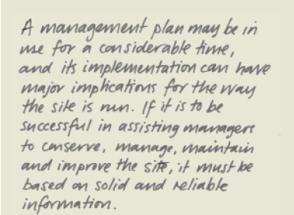

Appendix A1: Analysis of Survey Results:

Most people wanted the options presented, apart from the bog garden which was not especially popular. These options were: circumference all-weather path (to improve accessibility), Picnic benches, more sitting benches, and logs-stumps-natural-play-structures.
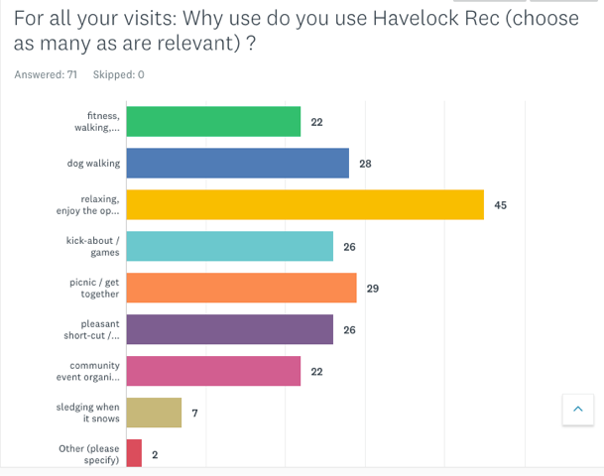
The suggestions in the free text with the highest number of mentions was “just as it is” (8 out of 44 / 18%), children’s playground (8 out of 44 / 18%) and outdoor gym equipment (6 out of 44 / 13%). Six people mentioned an-all-weather-perimeter path despite it being in the check boxes of the previous question. Other notable mentions are fox-proof bins, and proper gates on the Mornington and Homesdale Road entrances.
The survey response sheets were scanned and entered on Survey Monkey, so that the question could be made available on the web to non-park users.
The resulting charts:
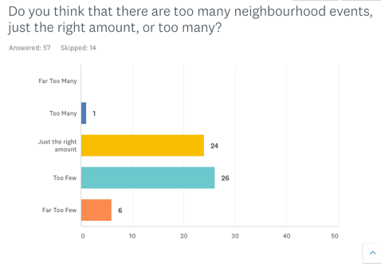 | 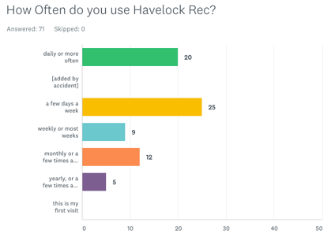 | 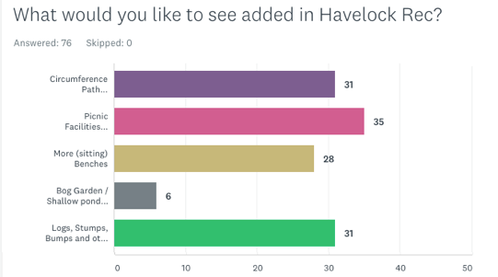

And the catchment bars shown on a map:

The full text answers to ‘What would you particularly like in the park?”
Excel Iindex | Data entry time | Comment
69 | 8/16/2018 7:54 AM | Walkways
67 | 8/16/2018 7:50 AM | Like it as it is
65 | 08/10/2018 22:51 | More long grass patches
64 | 08/10/2018 22:49 | I like it just as it is
63 | 08/10/2018 22:47 | Picnic benches would be great
62 | 08/10/2018 22:45 | Longer grass in patches; more wildflowers for bees & wildlife
60 | 08/10/2018 22:40 | More trees
59 | 08/10/2018 22:26 | Just as it is
58 | 8/10/2018 10:23 PM | Fitness Bars – Calisthenics
57 | 08/10/2018 22:20 | Pathway, flowers, obstacles
56 | 08/10/2018 22:17 | Raglan Road use it for Sports Day instead of concrete playground
55 | 08/10/2018 22:06 | Like it as it is
54 | 43381.91875 | A festival
52 | 08/10/2018 21:50 | Natural play area with trees
51 | 08/10/2018 21:46 | Pull-up bars
50 | 8/10/2018 9:44 PM | Festival or Fete
49 | 8/9/2018 5:43 PM | Landscaping (like the flowerbeds in Whitehall Rec)
48 | 8/9/2018 5:39 PM | Childrens Play Area
47 | 8/9/2018 5:36 PM | Left as it is
46 | 8/9/2018 5:36 PM | Gate on [Homesdale and Mornington Av] Entrances
45 | 08/09/2018 17:36 | All weather path, more bins / doggy bins, music (we like a band)
42 | 8/8/2018 7:46 PM | All weather path
41 | 8/8/2018 7:43 PM | Childrens playground
40 | 08/08/2018 19:41 | BBQ area and football posts
39 | 08/08/2018 19:40 | Fox proof bins. Tennis courts. Zip Wire.
38 | 08/08/2018 19:11 | I like it now
36 | 08/08/2018 19:03 | A refreshments hut manned by volunteers. Solar lighting.
35 | 08/08/2018 19:00 | I like it the way it is but with the recovery of the car park
33 | 08/08/2018 18:41 | Fun things
27 | 08/08/2018 13:33 | Playground
24 | 8/8/2018 1:23 PM | Small Playground
23 | 8/8/2018 1:21 PM | Playground for the kids, Information boards
22 | 8/8/2018 1:19 PM | Playground
19 | 8/8/2018 12:59 PM | Outdoor gym equipment
16 | 8/8/2018 12:43 PM | Litter bins and toilets
15 | 8/8/2018 12:39 PM | Shaded areas, Events for families
12 | 08/07/2018 18:47 | The whole point of Havelock Rec is that it's a decent size open space. It does not need nor want 'developing'. The point is openness. The point is space. This allows for wonder, imagination and freedom... benches allow us to appreciate it.
10 | 8/7/2018 6:38 PM | Some play equipment for the children or excerise equipment that they seem to be placing in parks now :)
9 | 8/7/2018 6:36 PM | An adventure playground using wood. One or two goal posts boys locally always playing footie. PIcnic area for those people who live in the flats and I think us residents would use.
8 | 8/7/2018 6:33 PM | Bar b que area, and outdoors fitness area
6 | 8/7/2018 6:20 PM | A pathway from one side to the other. Bark maybe to keep it natural
5 | 8/7/2018 6:18 PM | A small fenced in play area for the local children
2 | 8/7/2018 6:00 PM | suggest we get funding for outdoor gym equipment
1 | 08/06/2018 22:41 | An all weather perimeter trail for runners and buggies. Could have distance markers for the runners (like Dulwich Park) and make it possible to walk around it after rain with a buggy.
44 |  | number entries with text
 |  | Percentages

So the suggestions in the free text with the highest number of mentions was “just as it is” (8 out of 44 / 18%), children’s playground (8 out of 44 / 18%) and outdoor gym equipment (6 out of 44 / 13%). Six people mentioned an-all-weather-perimeter path despite it being in the options. Other notable mentions are fox-proof bins, and proper gates on the Mornington and Homesdale Road entrances.

The full text answers to ‘What would you particularly not want to see in the park?”

Excel ID | Data Entry Time | Showing 28 responses
69 | 08/10/2018 07:51 | Bromley Beacon Boys intimidating as they shout at you; they set their PE area up so close to the entrance they're in the way
1 | 08/10/2018 22:51 | More Buildings
1 | 08/10/2018 22:45 | Buildings / Development
1 | 08/10/2018 22:26 | Build Buildings
1 | 08/10/2018 22:20 | Buildings on the field
1 | 08/10/2018 22:17 | formal playground (as there's one at Whitehall Rec)
1 | 08/10/2018 22:06 | Any building on the land or cutting back the land for other use
1 | 08/10/2018 22:03 | Dog shit
1 | 08/10/2018 21:56 | A school
1 | 08/10/2018 21:44 | Like it as it is
1 | 08/08/2018 20:02 | Any Buildings
1 | 08/08/2018 19:59 | As it is, no buildings
1 | 08/08/2018 19:46 | Playground
1 | 08/08/2018 19:43 | Any big structures or anything that encourages teenagers
1 | 08/08/2018 19:41 | Pikeys
1 | 08/08/2018 19:40 | A school
1 | 08/08/2018 19:03 | Not a children's playground (cited conflict with dog walkers)
1 | 08/08/2018 18:48 | Buildings
1 | 08/08/2018 18:41 | Buildings
1 | 08/08/2018 18:37 | Smoke Shelter
1 | 08/08/2018 18:33 | Buildings
1 | 08/08/2018 13:34 | Houses
1 | 08/08/2018 13:33 | Construction
1 | 08/08/2018 13:19 | Cycling path
1 | 08/08/2018 13:14 | Buildings erected
1 | 08/08/2018 12:57 | Any buildings erected
1 | 08/08/2018 12:43 | Dog Mess
1 | 08/08/2018 12:39 | Being too built up
28 |  | count of responses
40.5 |  | of total responses

Despite the park not being under threat, 60% of respondents cited ‘buildings’ or ‘development’ as something they don’t want for the park.

